**CNG KIT CYLINDER & PARTS MANGEMENT SYSTEM**

**ENERGY ZONE**

**INTRODUCTION TO SOFTWARE ENGINEERING**

**DATE 26-June-2019**

**GROUP MEMBERS**

**MUHAMMAD UNAIS.17B-017-SE.SEM 1V SE-A**

**SHOAIB AHMED.17B-033-SE.SEM IV SE-A**

**HASSAN AHMED.17B-049-SE.SE A. SEM IV SE-A**

**ALI AKBAR.16B-056-SE. SEM IV SE-A**

**COURSE INSTRUCTOR**

**INSTRUCTOR NAME: USMAN WAHEED**

**PROJECT MANGER NAME: SHOAIB AHMED**

**USMAN INSTITUTE OF TECNOLOGY**

**CNG KIT AND MANGEMENT SYSTEM**

**MEMBERS**

**MUHAMMAD UNAIS.17B-017-SE.SEM 1V SE-A**

**SHOAIB AHMED.17B-033-SE.SEM IV SE-A**

**HASSAN AHMED.17B-049-SE.SE A. SEM IV SE-A**

**ALI AKBAR.16B-056-SE. SEM IV SE-A**

**ABSTRACT /EXECUTIVE SUMMARY**

The problem is to save and manage the information of the customer.it is not enough to taking customer information with in a quick time, there is a needed to separate the information of retailer and whole sales customer, there is a need to keep the data of the customer save for finance department. There is more information need to know and there is also a big problem to remember the parts and the price of it, there is difficult to taking information about kit repairing problem and to overcome the unnecessary information. The problem of managing the stock and the huge difficulty face is mange the account section and to handle all the data of the sales and purchase which is not easy and consume the time and the manual stored data in registers. We will solution which is define in detail in aims and statement of problem. In the future it will all change automatically by recording data into the software.

**TABLE OF CONTENTS**

CHAPTER # 1

INTRODUCTION AND OVERVIEW 8

**Aim and statement of problem:** 9

**Available Solution and Evaluation:** 9

**Analysis and Design:** 9

**Implementation:** 9

**Support:** 9

**References:** 9

**BACKGROUND** 102

CHAPTER # 2

AIM AND STATEMENT OF PROBLEM 13

**METHODS ASSUMPTION OF PROCEDURE** 14

**Structured programming** 14

**Advantages of structured programming** 14

**Disadvantages of structured programming** 14

**Information Engineering** 15

**Advantages** 15

**Disadvantages** 16

**Object-Oriented Software Engineering** 17

CHAPTER # 3

AVALIBLE SOLUTIONS AND EVALUATION 19

**PRODUCT 1** 19

**PRODUCT 2** 24

**PRODUCT 3** 30

CHAPTER # 4

ANALYSIS AND DESIGN 33

**Analysis Use Case Documentation** 33

**PURCHASE ITEM & SERVICE** 39

**Analysis Use case documentation (A)** 39

**Design Use case Documentation (D)** 40

**Sequence Diagram (D)** 40

**Input Design Prototype (D)** 40

**Output Design Prototype (D)** 40

**Class diagram (D) with control and interface classes** 40

**SALES ORDER** 41

**Analysis Use case documentation (A)** 41

**Design Use case Documentation (D)** 42

**Sequence Diagram (D)** 42

**Input Design Prototype (D)** 42

**Output Design Prototype (D)** 42

**Class diagram (D) with control and interface classes** 42

**VENDOR ORDER** 43

**Analysis Use case documentation (A)** 43

**Design Use case Documentation (D)** 44

**Sequence Diagram (D)** 44

**Input Design Prototype (D)** 44

**Output Design Prototype (D)** 44

**Class diagram (D) with control and interface classes** 44

**Database Diagram:** 45

CHAPTER # 5

Implementation 64

**Component diagram:** 64

**Deployment diagram:** 65

CHAPTER # 6

Support 66

**Conclusions and Suggestions for Future Work** 66

CHAPTER # 7

REFERENCE: 67

**Book Reference** 67

**Website Reference** 67

**APPENDICES:** 68

**BUSINESS DOCUMENT:** 71

**REVIEWED DOCUMENT:** 74

**LIST OF SYMBOLS** 79

GLOSSARY 89

**LIST OF FIGURES**

Figure 1.1 ACTIVITY DIAGRAM OF PURCHASE ITEMS AND SERVICE 10

Figure 2 ACTIVITY DIAGRAM OF PURCHASING & SELLING 10

Figure 3 CONTEXT DIAGRAM OF ENERGYZONE 11

Figure 4 OBJECT DIAGRAM PURCHASE AND SERVICE 34

Figure 5 OBJECT DIAGRAM SALE ORDER 35

Figure 6 OBJECT DIAGRAM VENDOR ORDER 36

Figure 7 ACTOR USE CASE OF ENERGYZONE 37

Figure 8 SEQUENCE DIAGRAM OF PURCHASE & SERVICE 42

Figure 9 CLASS DIAGRAM OF PURCHASE & SERVICE 45

Figure 10 SEQUENCE DIAGRAM OF SALES ORDER 49

Figure 11 CLASS DIAGRAM OF SALES ORDER 52

Figure 12 SEQUENCE DIAGRAM OF VENDOR ORDER 57

Figure 13 CLASS DIAGRAM OF VENDOR ORDER 61

Figure 14 DATABASE DIAGRAM OF PURCHASE ITEM 62

Figure 15 DATABASE DIAGRAM OF SALES ORDER 62

Figure 16 DATABASE DIAGRAM OF VENDOR ORDER 63

Figure 17 COMPONENT DIAGRAM OF ENERGY ZONE APPLICATION 64

Figure 18 DEPLOYMENT DIAGRAM OF ENERGY ZONE APPLICATION 65

**LIST OF TABLES**

Table 1 ACTOR USE CASE 37

Table 2 REPORT LIST TABLE 38

**Acknowledgments**

Firstly, we would like to thanks All Mighty Allah that we all are blessed with good health and skills and we would lie to thanks our Parents that they bring us to this level and full fill all our wishes and we would like to special thanks gratitude to our university director who support us as in every aspects to complete our project and our coarse instructor Prof. Mr. Usman Waheed for the continuous support of in our study and related research for the project, for his patience, motivation, and immense knowledge. His guidance helped me in all the time of research and help us the deliver the project. WE could not have imagined having a better advisor and mentor for our project. Also thanks to our group members by their contribution we make our project completely.

**CNG KIT AND MANGMENT SYSTEM**

**MEMBERS**

**MUHAMMAD UNAIS.17B-017-SE.SEM 1V SE-A**

**SHOAIB AHMED.17B-033-SE.SEM IV SE-A**

**HASSAN AHMED.17B-049-SE.SE A. SEM IV SE-A**

**ALI AKBAR16B—SE. SEM IV SE-A**

# INTRODUCTION AND OVERVIEW

The aim is to solve the Energy Zone issues which is been define above in abstract. We have acquire a Solution by analyzing anticipating design and maintain the data to solve the require problem which were describe and we have provide the solution in our design project which consist of

**CNG department** which starts by taking the information about customer that he or she had repairing problems or they might have to fit the kit and check service if they have to fit CNG kit we will check availability of that and then we install it. If there is some problem we sent the employee what is the problem and what spare parts are needs to be fit if he agree then we fit it. When all the work has done then customer ask for payment ways there are three payments options are available which are cash cheque (which is verified) and direct account which is given account no then check payment is done which is recorded in Finance and also recorded in customer software then they are given receipt of the following parts and Kit along with transition’s.

The **Vendor and Retailer department** which starts by taking information of customer then it will take the information of parts and then determine whether needs to sell or purchase if he is selling then we are checking the stock after then all the requirement’s full fill we are telling about for payment ways there are three payments options are available which are cash cheque (which is verified) and direct account which is given account no then check payment is done which is recorded in Finance and also recorded in customer software then they are given receipt of the following parts and Kit along with transition’s. If he is purchasing we are telling about for payment ways there are three payments options are available which are cash cheque (which is verified) and direct account which is given account no then check payment is done which is recorded in Finance and also recorded in customer software then they are given receipt of the following parts and Kit along with transition’s.

**Service Employee** includes the perform of the repairing of the vehicle and telling the customers about the problem and give response what are the problem in the vehicle and what are require. Then we are checking the availability of the service employee whether he is free or not. The System save the data of the service employee and there amount of salaries giving month wise and then give the summary of data about it.

**Stock House** the system consist of a record of stock house what are the part available in it and then the system responds against what items are available in how much quantity.

**Finance Department** the system consist of a finance department which include all the records of the transactions and the finance department check whether the cheque is ok. Verify the account no and make the various sales and purchase reports.

## **Aim and statement of problem:**

In this chapter we have describe the aim statement of the problem and describe how the problem is been solved.

## **Available Solution and Evaluation:**

In this chapter we describe the application which is some similar to our application.

## **Analysis and Design:**

In this chapter we have the overall process of our project how it can be down thorugh several diagrams.

## **Implementation:**

In this chapter we discuss the component and deployment diagram of our project.

## **Support:**

In this chapter we describe the supportive contract with the organization.

## **References:**

In this chapter we see reference that is useful to our project. Also see that work that was to making this project in appendences. In the we discuss some UML notation that was very useful to or project diagram.

## **BACKGROUND**

The Existing system Consist of a login which is used by the admin and all the data of all the departments is entered by the admin and they are unsuccessful to solve the organization problem.

**Activity Diagram**

In this we describe the overall workflow or activity diagram of our organization.

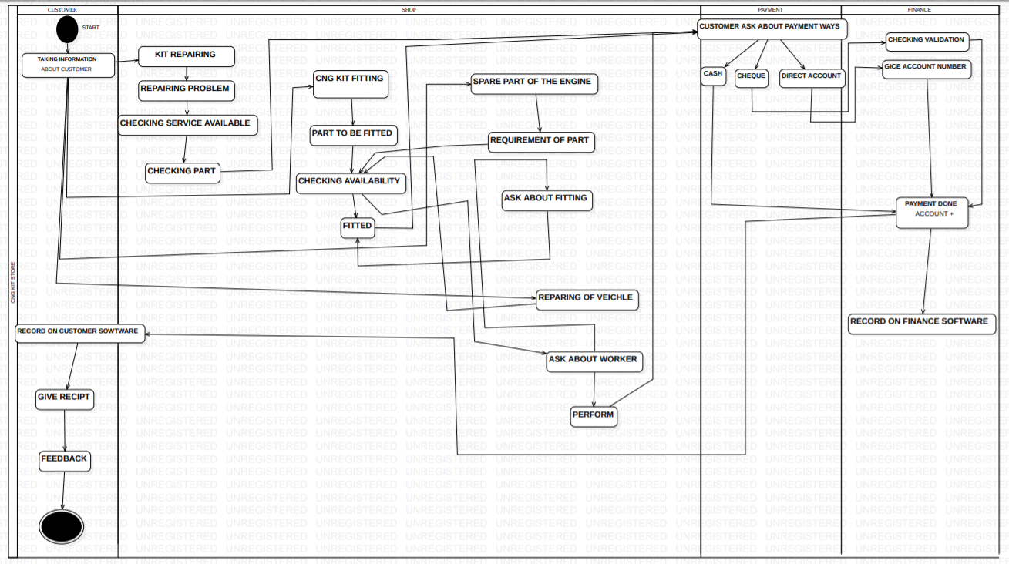

Figure .1 ACTIVITY DIAGRAM OF PURCHASE ITEMS AND SERVICE

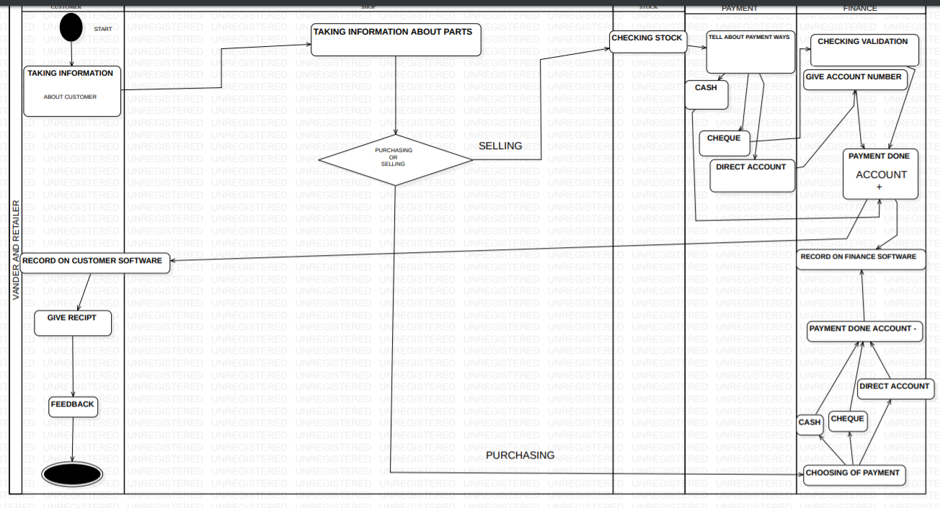

Figure ACTIVITY DIAGRAM OF PURCHASING & SELLING

In **Figure 1** the customer enters the shop then he is offer kit fittings, Repairing of the vehicles, Spare parts when he avail the service then he is ask about the customers to payments of cash, cheque and direct account so he can complete the purchase.

If the customer ask for the repair of the vehicle or the spare parts of the engine then we will provide the spare parts of the vehicle and ask him for the fittings of the when all the work is completed he is he is ask about the customers to payments of cash, cheque and direct account so he can complete the purchase.

In **Figure 2** the vendor gives the items and then he is paid for his delivery of the items, The retailer then given the parts which he demand and pay the amount against the demanded parts then the record is save of the retailer and vendor.

**Context Diagram**

In this we describe context diagram of our organization.

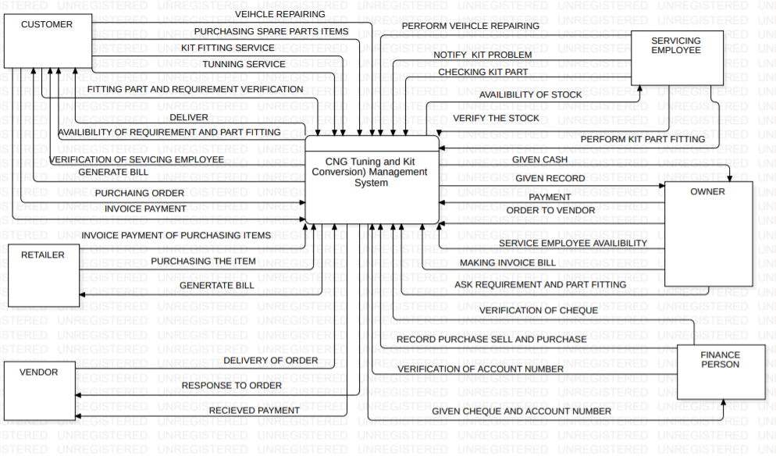

Figure CONTEXT DIAGRAM OF ENERGYZONE

In **Figure 3** the customer can interact with the system that he needs to repair vehicle, purchase spare parts, kit fittings and he can avail tuning services then the system will provide him the fittings of the parts and requirement of verification and will provide the availability and parts requirement’s that is needed, the system also verify the service employee that he is available or not. Then the system will generate bill to the customer and to pay the require amount. The vendor gives the items and then he is paid for his delivery of the items, The retailer then given the parts which he demand and pay the amount against the demanded parts then the record is save of the retailer and vendor. The service employee interact by performing the operation which where reacquired, he will check all the problems which are faced by the customers. The service employee will check the availability of the stock whether the stock is available or not. The owner interacts with the system by giving order and payment to the vendor. The system will give him the record of the data and the owner will provide the invoice of the purchase items. The Finance interact with the system by recording the transition of sales and purchase and they need to verify the check given by the customer and retailer and they also need to verify the account no, the system then responds to provide the check and account no to the finance department.

# AIM AND STATEMENT OF PROBLEM

The Organization was establish in 2003 these Organization deal in the CNG kit fitting repair of the vehicle and sales the parts of the vehicles in whole sale and retail to its buyers it buy the product from different vendors and have different employee which were handle different task, the problem is to save and manage the information of the customer is it not enough to taking customer information with in a quick time, there is a needed to separate the information of retailer and whole sales customer, there is a need to keep the data of the customer save for finance department. There is more information need to know and there is also a big problem to remember the parts and the price of it, there is difficult to taking information about kit repairing problem and to overcome the unnecessary information. The problem of managing the stock and the huge difficulty face is mange the account section and to handle all the data of the sales and purchase which is not easy and consume the time and the manual stored data in registers.

We have acquire a Solution by analyzing anticipating design and maintain the data to solve the require problem which were describe and we have provide the solution in our design project which consist of

1. **CNG department**
2. **The Vendor and Retailer department**
3. **Service Employee**
4. **Stock House**
5. **Finance Department**

## **METHODS ASSUMPTION OF PROCEDURE**

**Structured programming** (sometimes known as modular **programming**) is a subset of procedural **programming** that enforces a logical **structure** on the **program** being written to make it more efficient and easier to understand and modify. ... **Structured programming** was first suggested by Corrado Bohm and Guiseppe Jacopini.

## **Advantages of structured programming**

The following are the different advantages of structured programming

1. It is user friendly and easy to understand.
2. Similar to English vocabulary of words and symbols.
3. It is easier to learn.
4. They require less time to write.
5. They are easier to maintain.
6. These are mainly problem oriented rather than machine based.
7. Program written in a higher level language can be translated into many machine languages and therefore can run on any computer for which there exists an appropriate translator.
8. It is independent of machine on which it is used i.e. programs developed in high level languages can be run on any computer.

## **Disadvantages of structured programming**

The following are the disadvantages of structured programming:

1. A high level language has to be translated into the machine language by translator and thus a price in computer time is paid.
2. The object code generated by a translator might be inefficient compared to an equivalent assembly language program.
3. Data type are proceeds in many functions in a structured program. When changes occur in those data types, the corresponding change must be made to every location that acts on those data types within the program. This is really a very time consuming task if the program is very large.
4. Let us consider the case of software development in which several programmers work as a team on an application. In a structured program, each programmer is assigned to build a specific set of functions and data types. Since different programmers handle separate functions that have mutually shared data type. Other programmers in the team must reflect the changes in data types done by the programmer in data type handled. Otherwise, it requires rewriting several functions.

**Information Engineering** has a somewhat chequered history that follows two very distinct threads. It originated in [Australia](https://en.wikipedia.org/wiki/Australia) between 1976 and 1980, and appears first in the literature in a series of Six In-depth articles by the same name published by US Computerworld in May - June 1981.[[1]](https://en.wikipedia.org/wiki/Information_engineering#cite_note-1) Information technology engineering first provided [data analysis](https://en.wikipedia.org/wiki/Data_analysis) and [database design](https://en.wikipedia.org/wiki/Database_design) techniques that could be used by [database administrators](https://en.wikipedia.org/wiki/Database_administrator) (DBAs) and by [systems analysts](https://en.wikipedia.org/wiki/Systems_analyst) to develop database designs and systems based upon an understanding of the operational processing needs of organizations for the 1980s.

The competitiveness of most companies is in a large degree based on the effective use of information technologies and information systems especially. The main purpose of information systems are provide the right information to the right people at the right time. It is used to track, store, manipulate and distribute the information from gathered data to appropriate persons when necessary.

In this post I thought to think about what advantages and disadvantages can bring to the businesses and society the integrating information systems. Of course, without any doubt the efficient usage of information systems will give a lot opportunities to the companies and advantages to their business. Sometime it can make kind of new job environments but on the other hand it can make some group of employees unemployed.

## **Advantages**

**Communication** – with help of information technologies the instant messaging, emails, voice and video calls becomes quicker, cheaper and much efficient.

**Globalization and cultural gap**– by implementing information systems we can bring down the linguistic, geographical and some cultural boundaries. Sharing the information, knowledge, communication and relationships between different countries, languages and cultures becomes much easier.

**Availability** – information systems has made it possible for businesses to be open 24×7 all over the globe. This means that a business can be open anytime anywhere, making purchases from different countries easier and more convenient. It also means that you can have your goods delivered right to your doorstep with having to move a single muscle.

**Creation of new types of jobs –**one of the best advantages of information systems is the creation of new and interesting jobs. Computer programmers, Systems analyzers, Hardware and Software developers and Web designers are just some of the many new employment opportunities created with the help of IT.

**Cost effectiveness and productivity**– the IS application promotes more efficient operation of the company and also improves the supply of information to decision-makers; applying such systems can also play an important role in helping companies to put greater emphasis on information technology in order to gain a competitive advantage. IS has a positive impact on productivity, however there are some frustrations can be faced by systems users which are directly linked to lack of training and poor systems performance because of system spread.

## **Disadvantages**

**Unemployment and lack of job security**– implementing the information systems can save a great deal of time during the completion of tasks and some labor mechanic works. Most paperwork’s can be processed immediately, financial transactions are automatically calculated, etc. As technology improves, tasks that were formerly performed by human employees are now carried out by computer systems. For example, automated telephone answering systems have replaced live receptionists in many organizations or online and personal assistants can be good example also. Industry experts believe that the internet has made job security a big issue as since technology keeps on changing with each day. This means that one has to be in a constant learning mode, if he or she wishes for their job to be secure.

**Dominant culture –**while information technology may have made the world a global village, it has also contributed to one culture dominating another weaker one. For example it is now argued that US influences how most young teenagers all over the world now act, dress and behave. Languages too have become overshadowed, with English becoming the primary mode of communication for business and everything else.

**Security issues** – thieves and hackers get access to identities and corporate saboteurs target sensitive company data. Such data can include vendor information, bank records, intellectual property and personal data on company management. The hackers distribute the information over the Internet, sell it to rival companies or use it to damage the company’s image. For example, several retail chains were targeted recently by hackers who stole customer information from their information systems and distributed Social Security numbers and credit card data over the Internet.

**Implementation expenses** – to integrate the information system it require pretty good amount of cost in a case of software, hardware and people. Software, hardware and some other services should be rented, bought and supported. Employees need to be trained with unfamiliar information technology and software. Information systems contribute to the efficient running of organizations. Information systems are showing the exponential growth in each decades. Today’s information technology has tremendously improved quality of life. Modern medicine has benefited the most with better information system using the latest information technology. By understanding and learning what advantages and disadvantages it can bring, we have to try, believe and put an effort with our best to make that existing advantage much better and navigate the disadvantages to have a less impact on organizations and society.

**Object-Oriented Software Engineering** (OOSE) : is a **software** design technique that is used in **software** design in **object**-**oriented** programming. OOSE is developed by Ivar Jacobson in 1992. OOSE is the first **object**-**oriented** design **methodology** that employs use cases in **software** design.

**Advantages**

The system will enjoy a longer life while having far smaller maintenance costs.  Because most of the processes within the system are encapsulated, the behaviors may be reused and incorporated into new behaviors.

**Real-World Modeling:**Object-oriented system tend to model the real world in a more complete fashion than do traditional methods.  Objects are organized into classes of objects, and objects are associated with behaviors.  The model is based on objects, rather than on data and processing.

**Improved Reliability and Flexibility:** Object-oriented system promise to be far more reliable than traditional systems, primarily because new behaviors can be "built" from existing objects. Because objects can be dynamically called and accessed, new objects may be created at any time.  The new objects may inherit data attributes from one, or many other objects.  Behaviors may be inherited from super-classes, and novel behaviors may be added without effecting existing systems functions.

**High Code Reusability:**When a new object is created, it will automatically inherit the data attributes and characteristics of the class from which it was spawned.  The new object will also inherit the data and behaviors from all super classes in which it participates.  When a user creates a new type of a widget, the new object behaves "wigitty", while having new behaviors which are defined to the system.

**Disadvantages Object-oriented Development is not a panacea**- Object-oriented Development is best suited for dynamic, interactive environments, as evidenced by its widespread acceptance in CAD/CAM and engineering design systems.  Wide-scale object-oriented corporate systems are still unproved, and many bread-and-butter information systems applications (i.e. payroll, accounting), may not benefit from the object-oriented approach.**Object-oriented Development is not a technology** - Although many advocates are religious in their fervor for object-oriented systems, remember that all the "HOOPLA" is directed at the object-oriented approach to problem solving, and not to any specific technology.

**Object-oriented Development is not yet completely accepted by major vendors -**Object-oriented Development has gained some market respectability, and vendors have gone from catering to a "lunatic fringe" to a respected market.  Still, there are major reservations as to whether  Object-oriented development will become a major force, or fade into history, as in the 1980's when Decision Support Systems made great promises, only to fade into obscurity.

We are using the object oriented because it help in solve the real world problem and it is very powerful programming language as compare to Structured and Informational engineering. For it we have design the work flow, Context diagram, actor use case diagram and its analysis design narration, sequence diagram, data base diagram, state transitional diagram, Component and deployment diagram and we have implemented by c#.

# AVALIBLE SOLUTIONS AND EVALUATION

There are different websites are available for the solution to the problems which acquire the data but will not provide a relevant solution because the data which is been capture there is been change such as the website which belongs to India provide other thing which things are no require the client’s needs.

We are developing which solve the client problems which were discus above, we capture the data what they need and understand and help them to solve it.

We have search three websites which are as flow:

## **PRODUCT 1**

**WEB ADDRESS:**

[***https://www.cngunited.com/***](https://www.cngunited.com/)

**COMPANY NAME:**

***CNG UNITED***

**PRODUCTS NAME:**

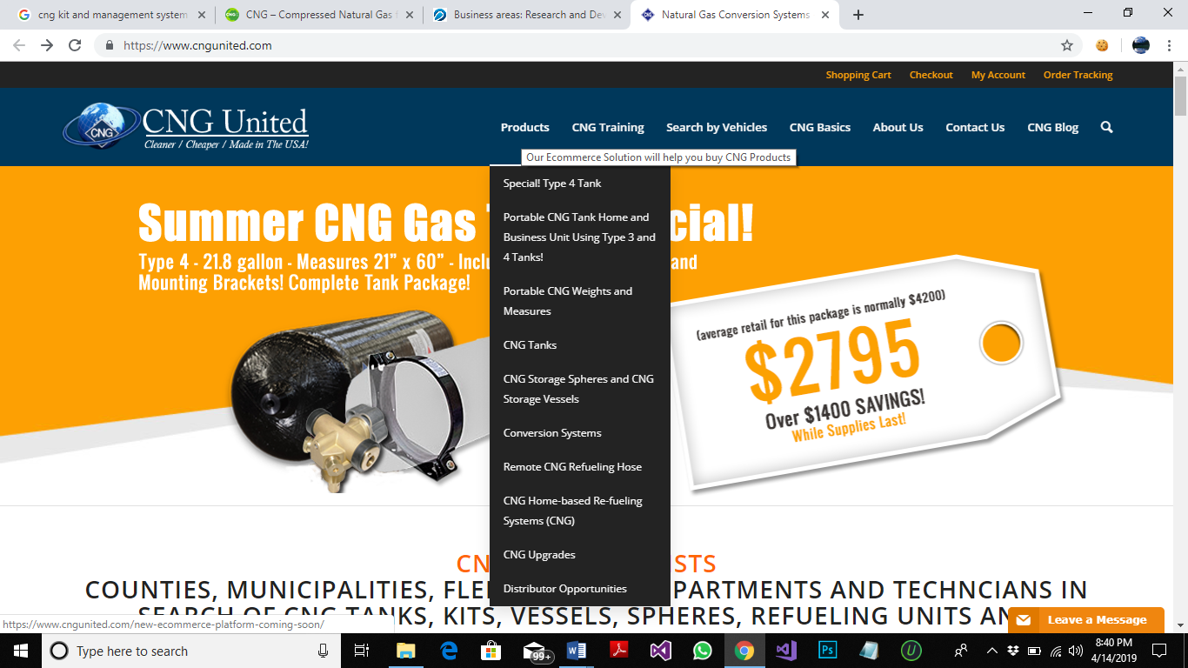

**FEATURES:**

1. SHOPPING CART
2. CHECK OUT SYSTEM
3. ORDER TRAKING SYSTEM
4. REGISTRATION OF CUSTOMERS
5. PRODUCT SUPPORT MESSAGE
6. SEARCH ENGINE
7. SEARCH BY VEHICLE
8. SEARCH OF CNG TANKS, KITS, VESSELS, SPHERES, REFUELING UNITS AND COUNTY WEIGHTS & MEASURE UNITS
9. PROVIDE INFORMATION WHICH LOCATION IN THE VEHICLE PART TO BE FITTED
10. PROVIDE INFORMATIVE VIDEOS
11. CNG BLOG NEWS AND STORIES

**INTERFACES:**



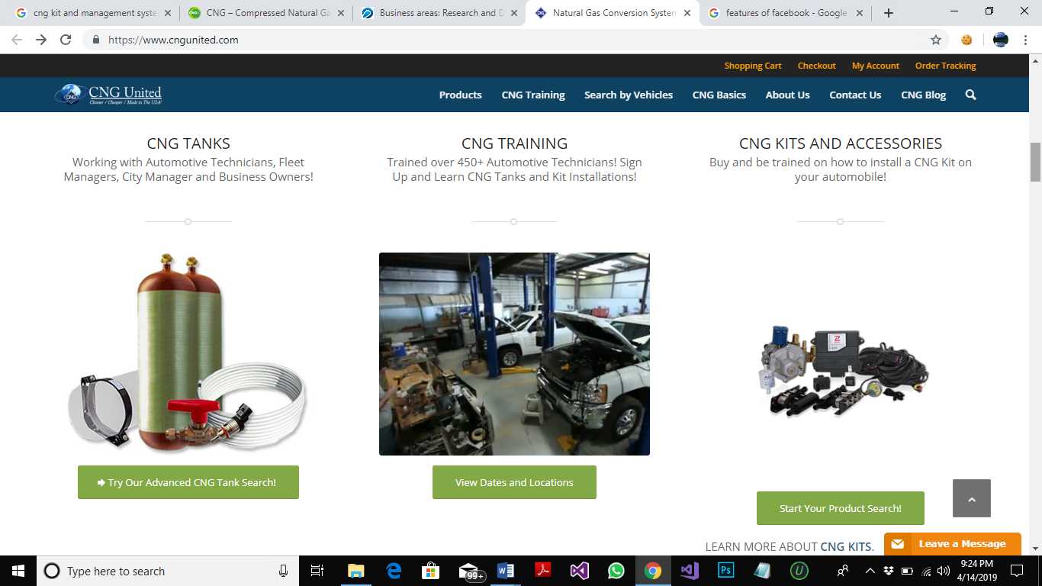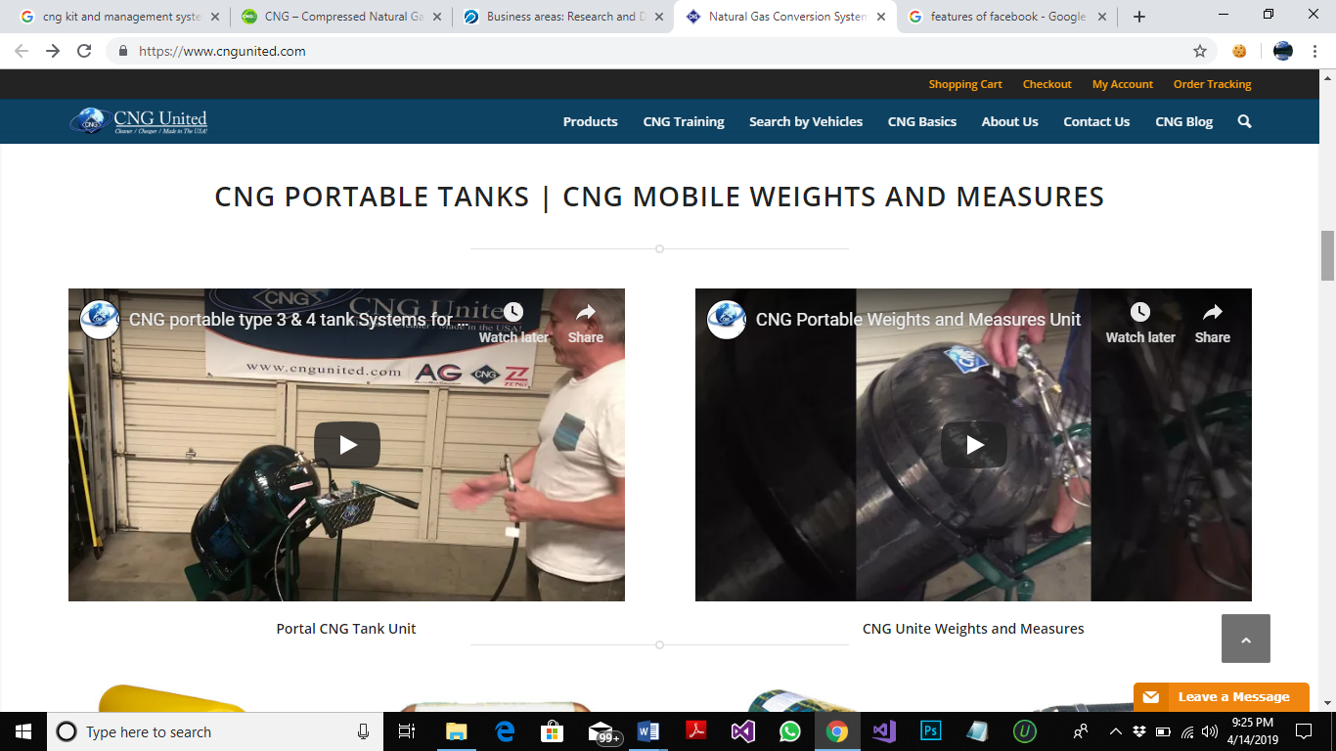

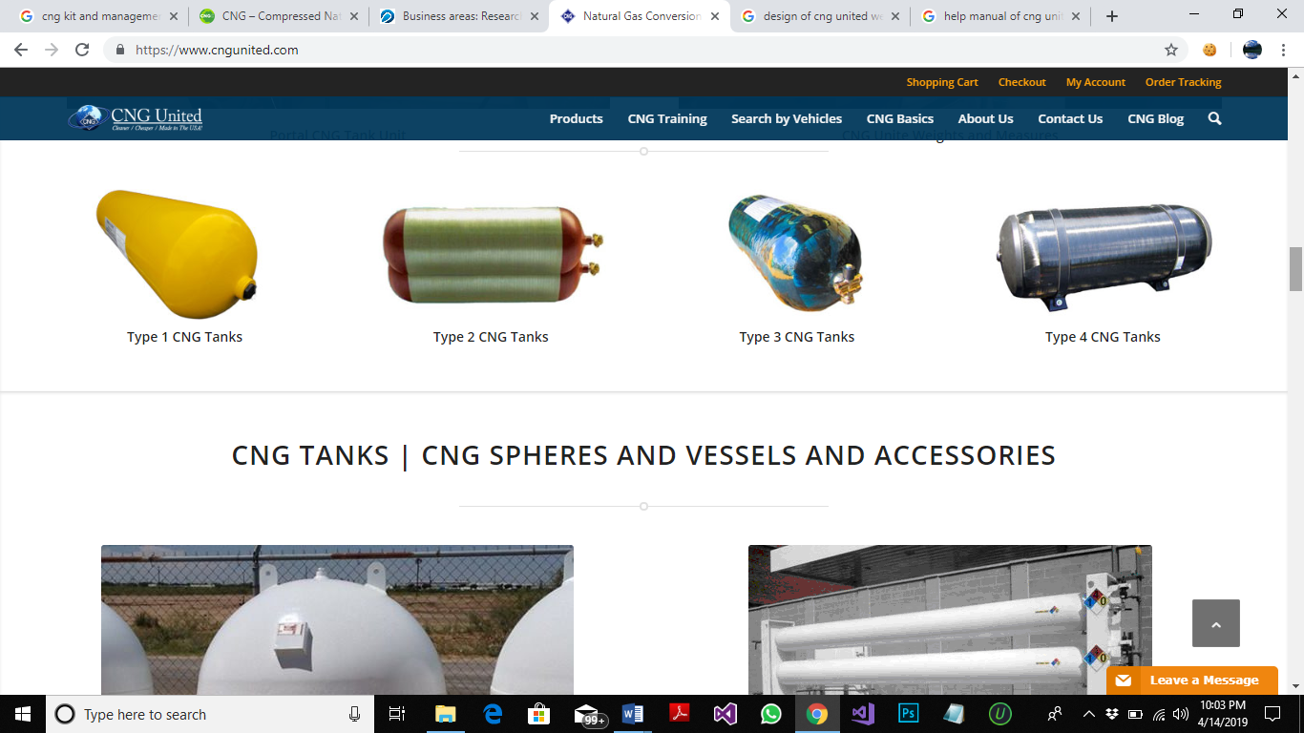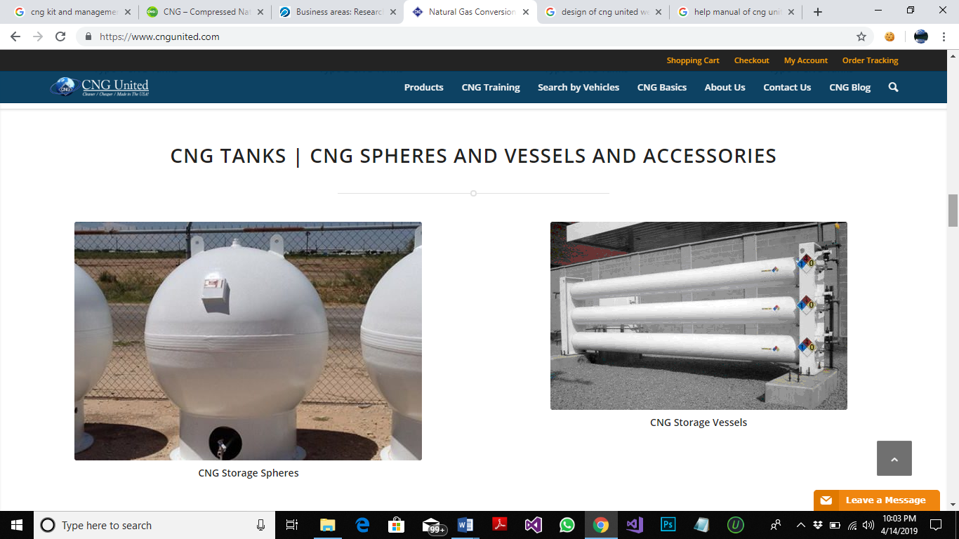

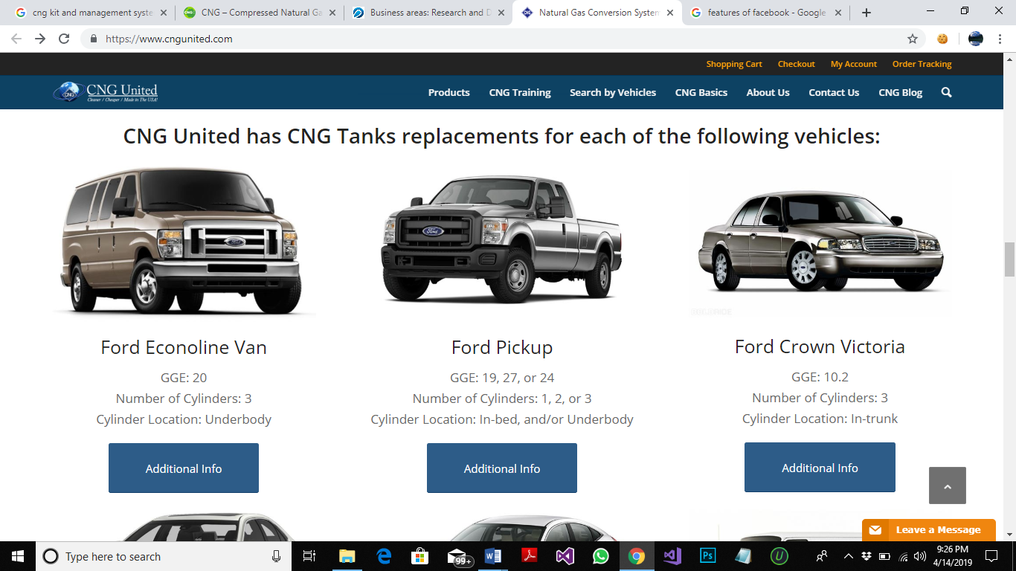 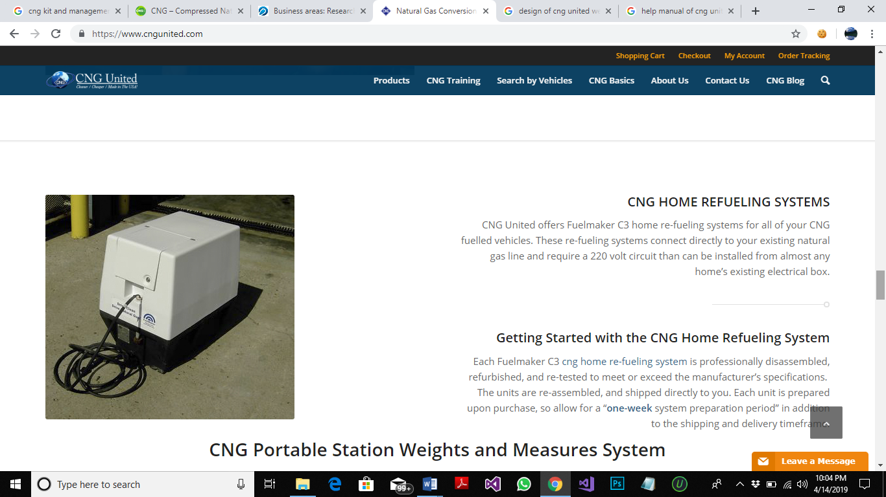

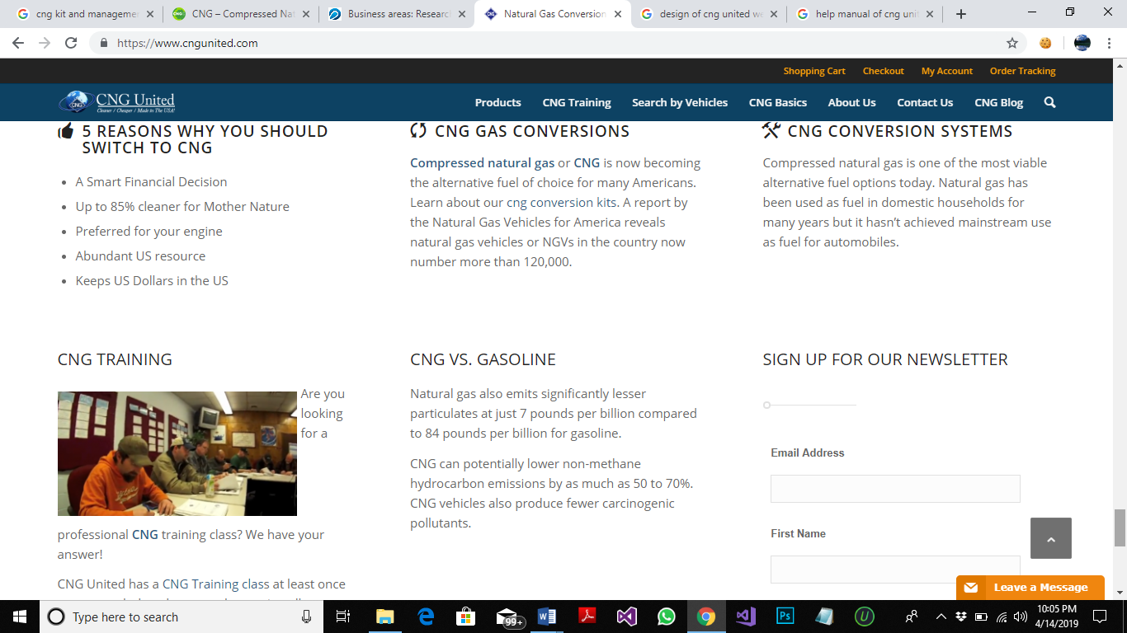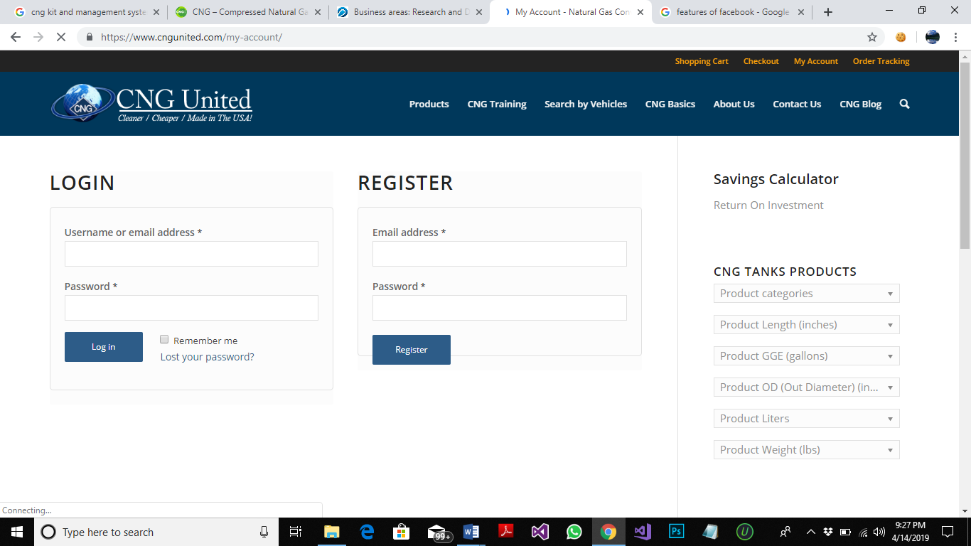

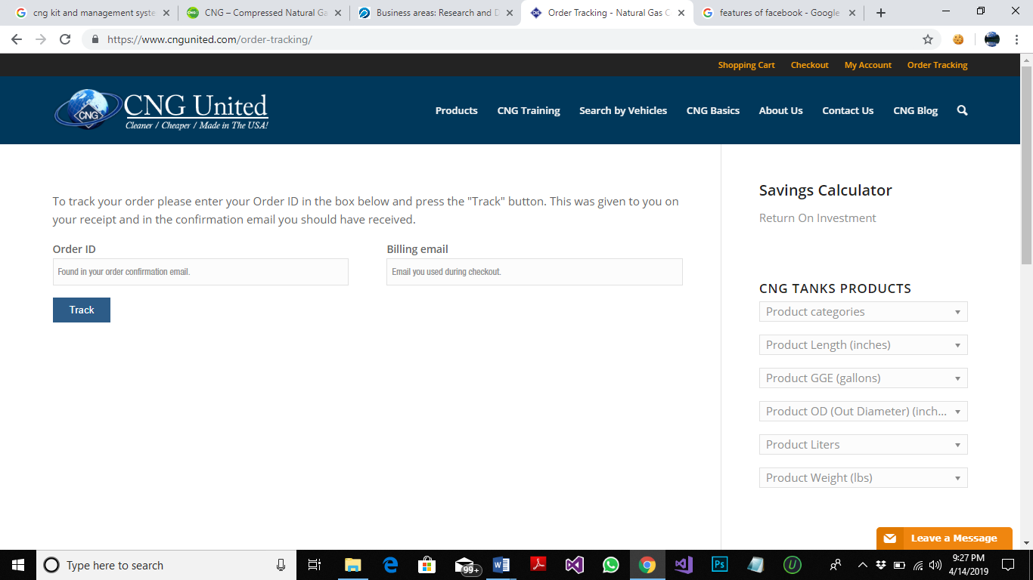

**COST:**

Not given

**DESIGN:**

DESIGN AND DEVELOPED BY **(Will2Design)**

## 

## **PRODUCT 2**

**WEB ADDRESS:**

[**https://www.indiamart.com**](https://www.indiamart.com/)

**COMPANY NAME:**

***NONE***

**PRODUCTS NAME:**

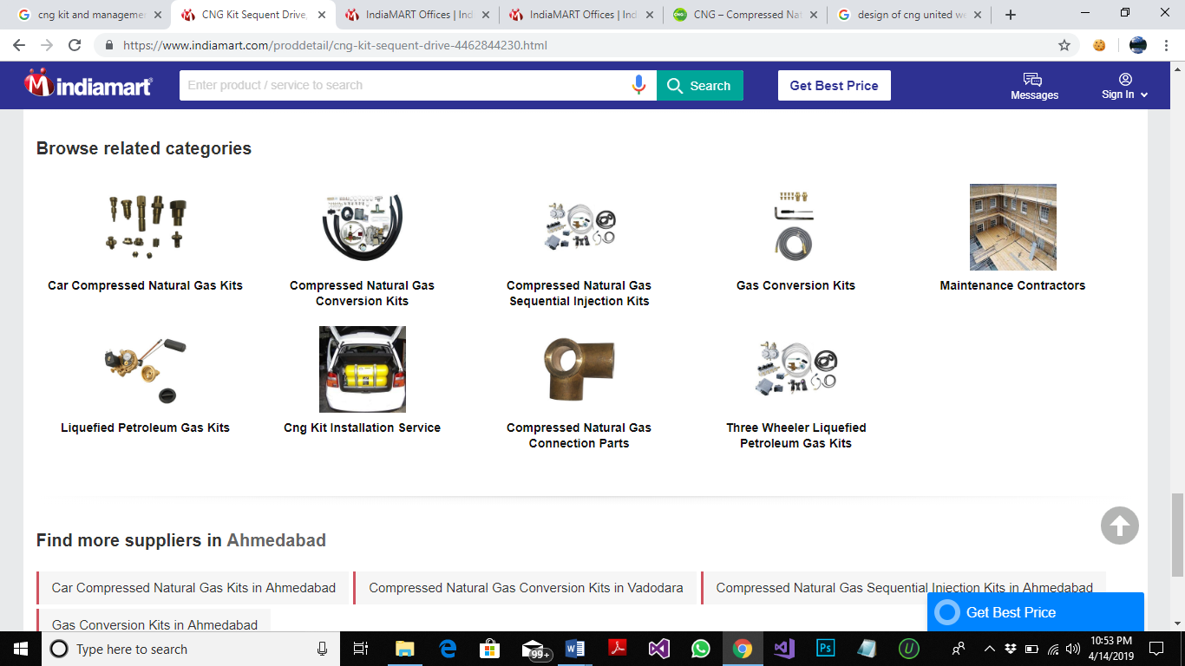

**FEATURES:**

1. SIGN IN OPTION
2. LATEST PRICE
3. DISPLAY PAYMENT METHOD, RECENT ACTIVITIES, CONTACT PROFILE IS PROVIDED.
4. SUBMIT REQUIREMENTS
5. COMPANY DETAILS AND PRODUCT DETAILS
6. SEND INQUIRY TO SUPPLIER
7. COMPLAINT,FEEDBACK AND HELP
8. TOP AND LATEST SUPPLIER DETAILS
9. SEARCH ENGINE OF PRODUCT AND SERVICES
10. FIND SUPPLIERS BY REGIONS
11. PROVIDE BUSINESS CATEGORIES DETAILS
12. BUSINESS TYPE (RETAILER ,WHOLESALER OR MANUFACTURE)

**INTERFACES:**

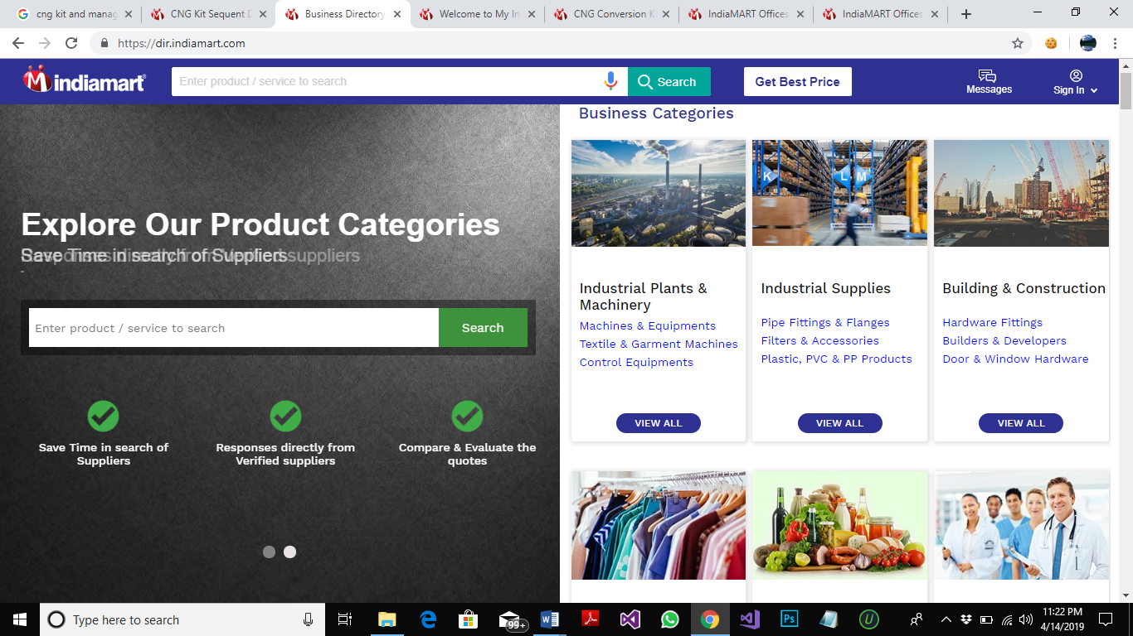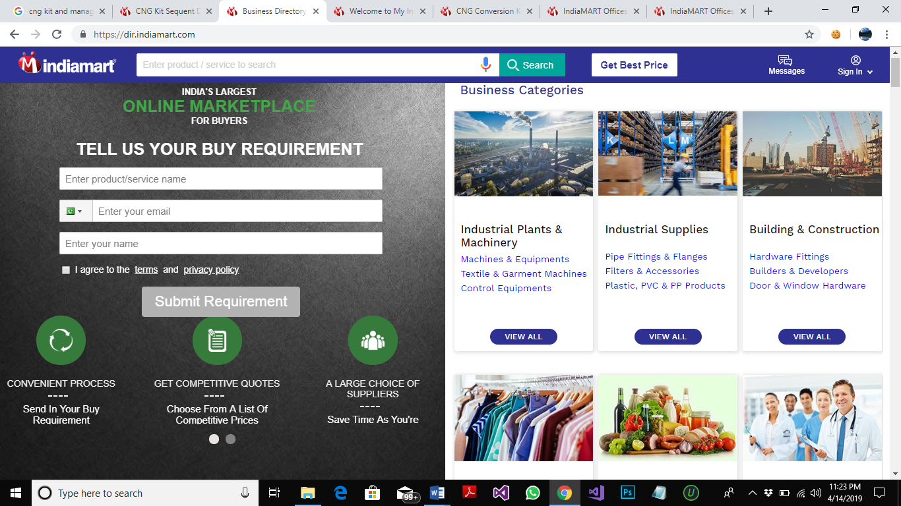

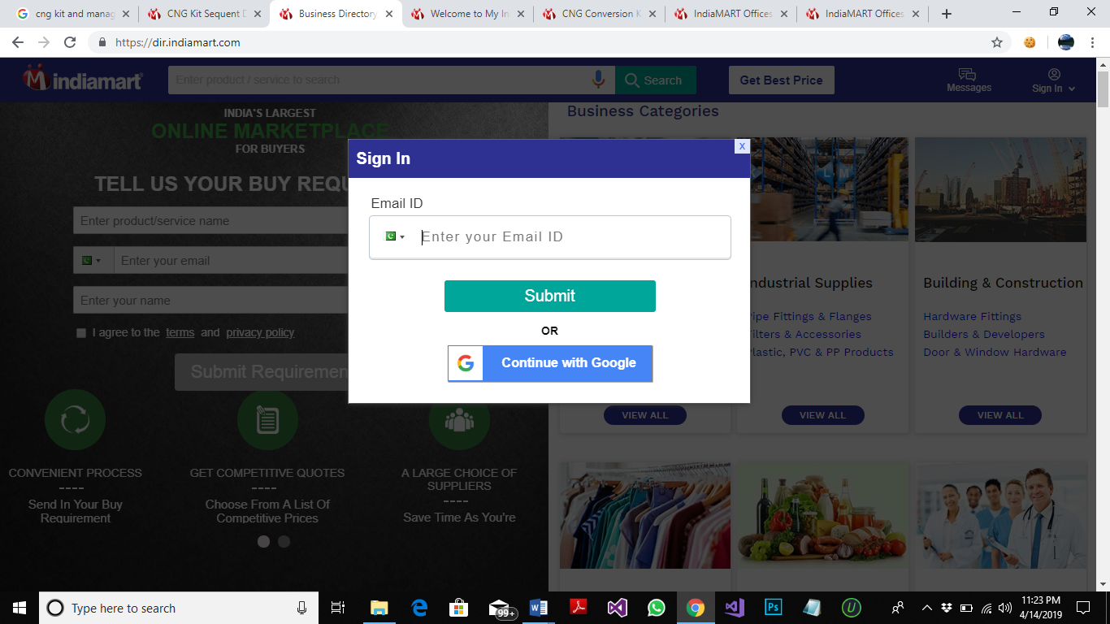 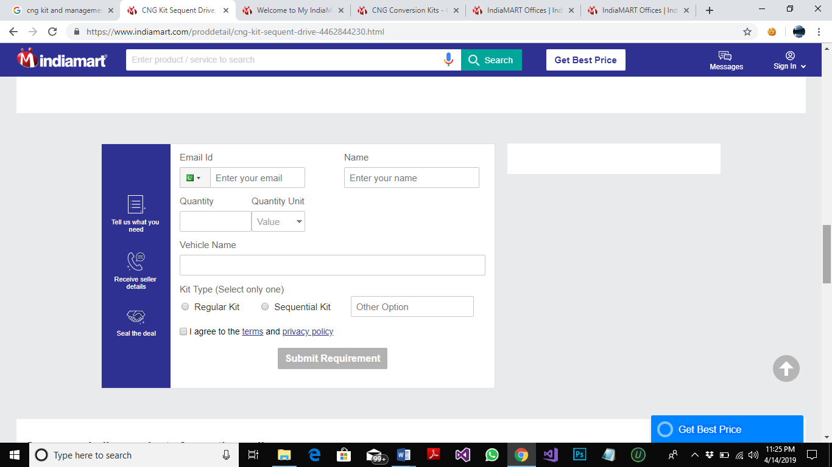 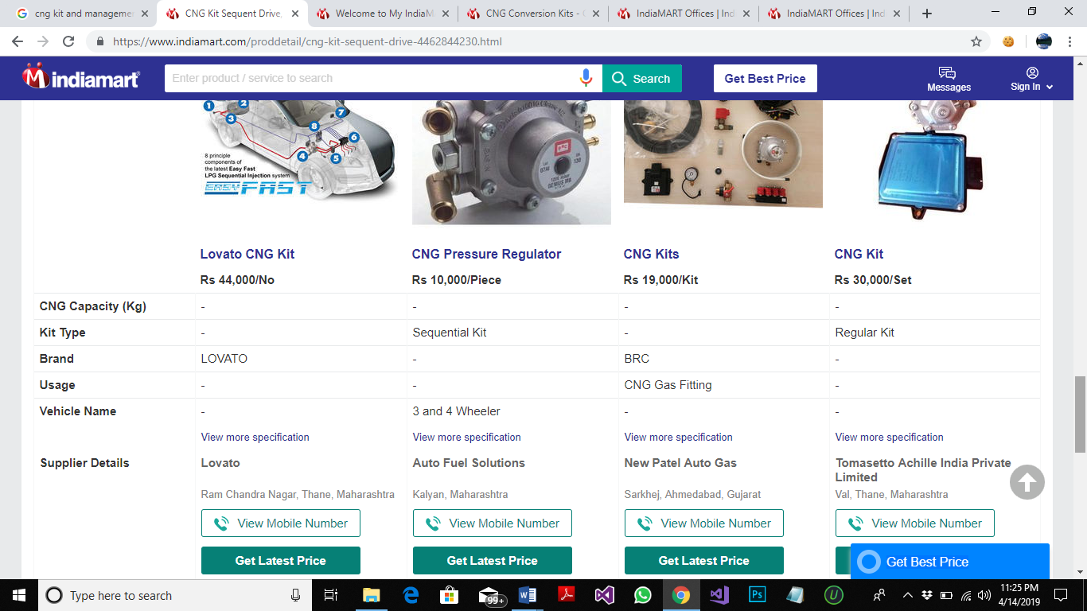 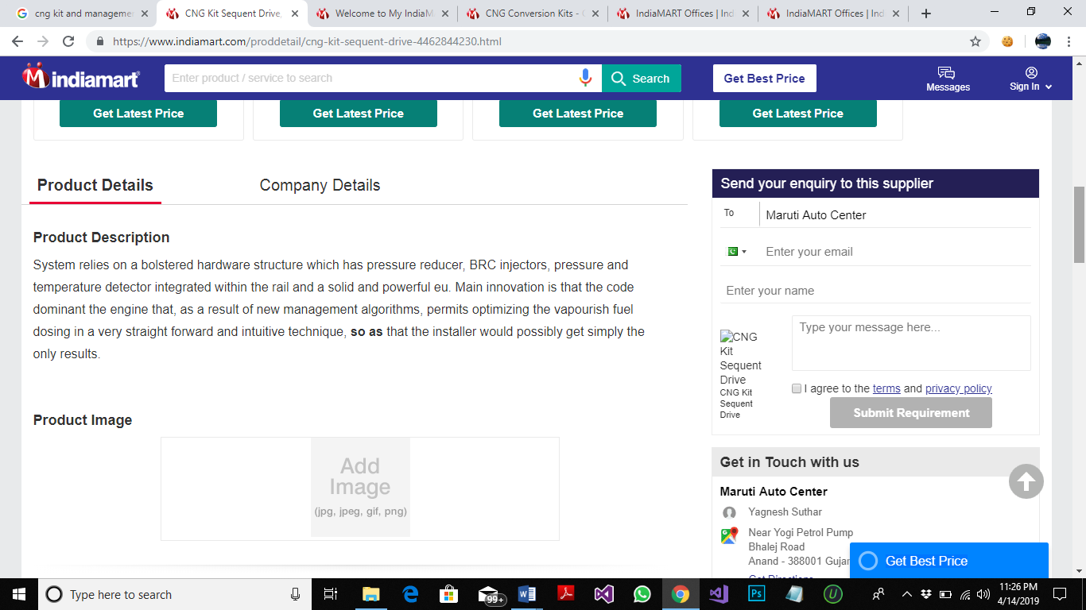

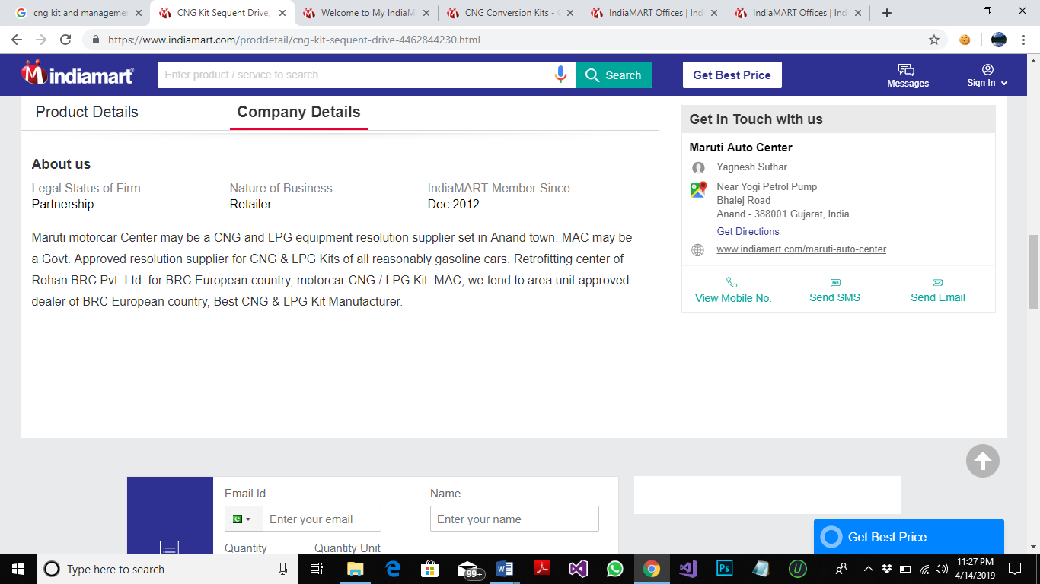

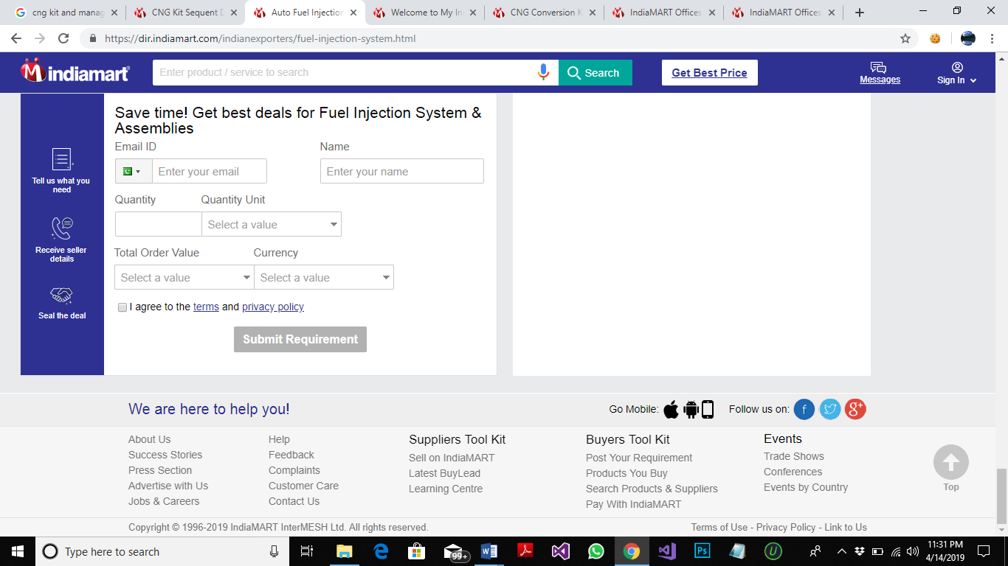 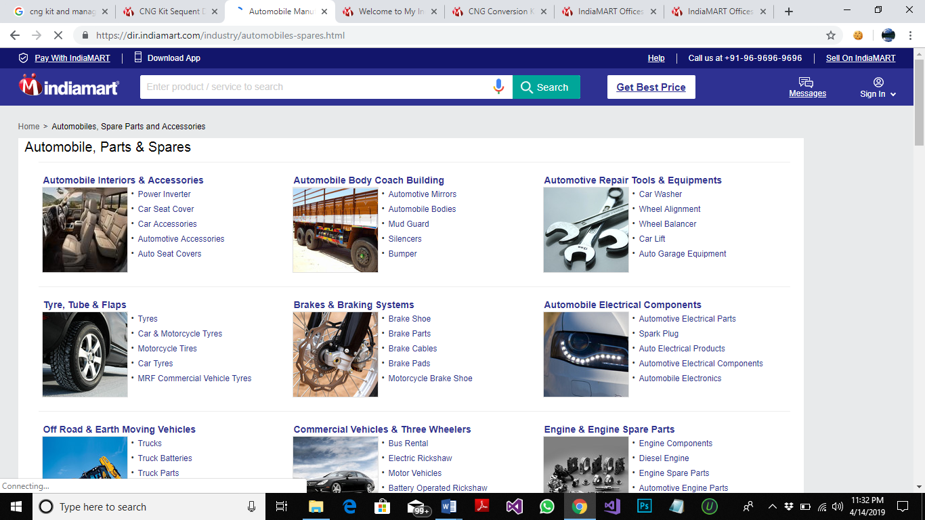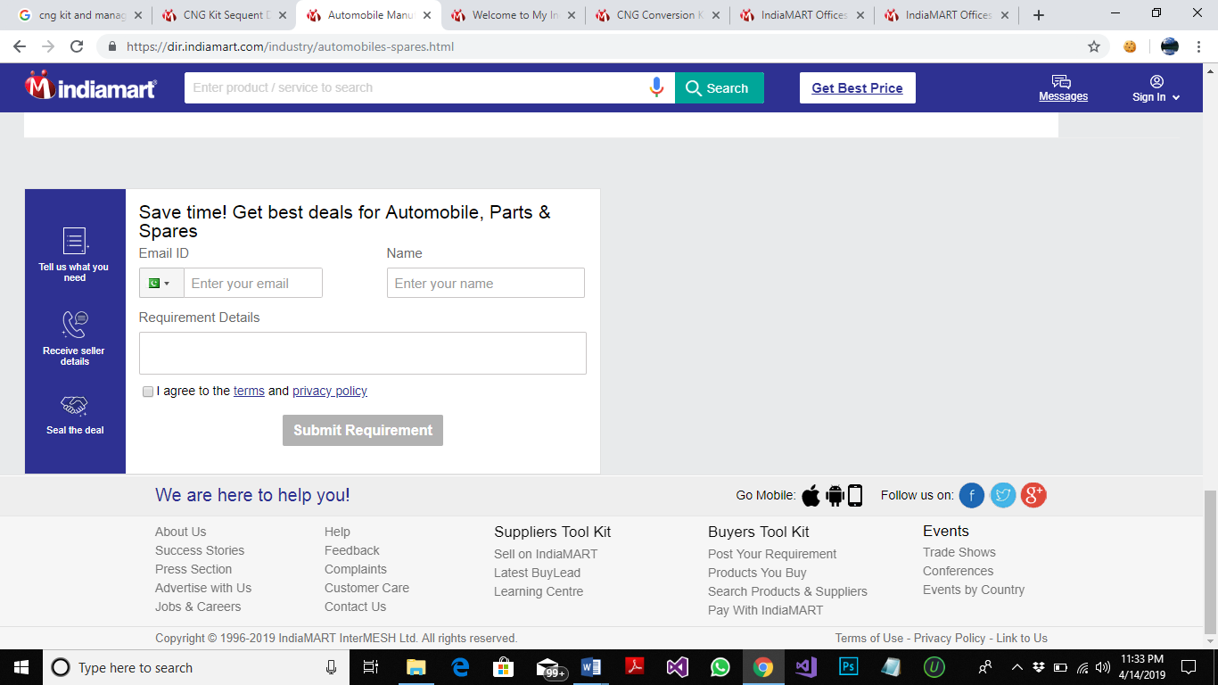

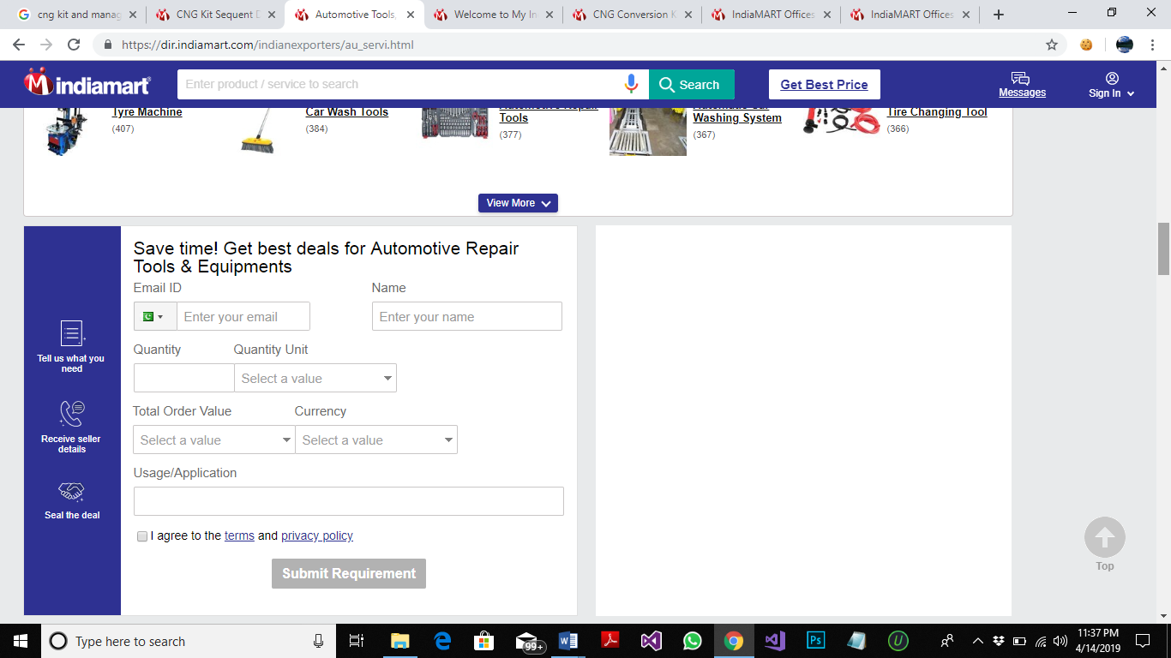 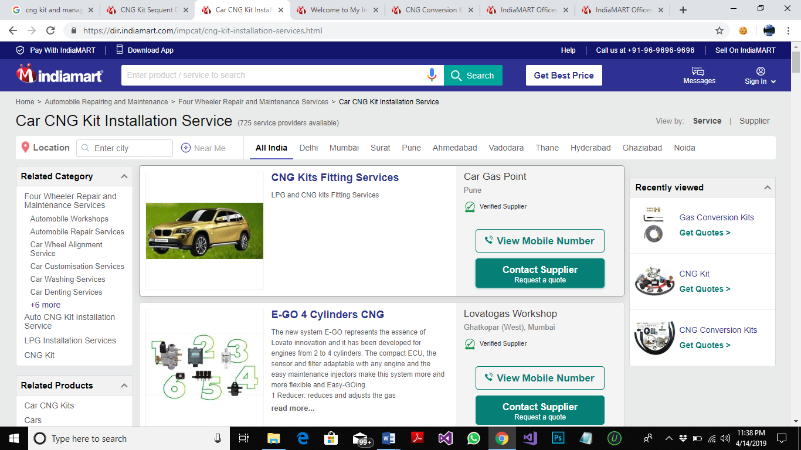

**COST:**

NOT PROVIDED

**TECHNOLOGY USED:**

ANDROID APP, IOS APP AND WEB BASE APPLICATION

**WORKFLOW:**

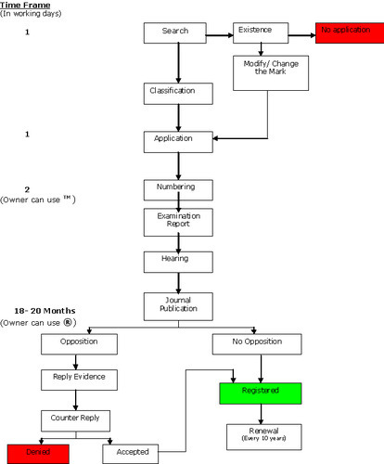

## **PRODUCT 3**

**WEB ADDRESS:**

[***https://www.tomasetto.com/***](https://www.tomasetto.com/)

**COMPANY NAME:**

***TOMASETTO ACHILLES***

**PRODUCTS NAME:**

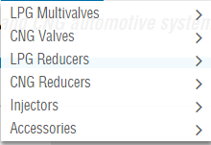

**FEATURES:**

1. CUSTOMER LOGIN SYSTEM
2. CHECK OUT SYSTEM
3. ORDER TRAKING SYSTEM
4. REGISTRATION OF CUSTOMERS
5. PRODUCT SUPPORT MESSAGE
6. CUSTOMER CARE TO LIKE FAQ QUESTIONN TO KEEP THEM AWARE OF WHAT PROBLEM THEY MIGHT BE FACING.
7. NEWS SERVICE ABOUT EXIBITION AND EVENTS AND ALSO NEWS ABOUT NEW PRODUCTS IN MARKET.
8. COMPANY INFORMATION TO MAKE THE CUSTOMER SATISFIED.

**INTERFACES:**

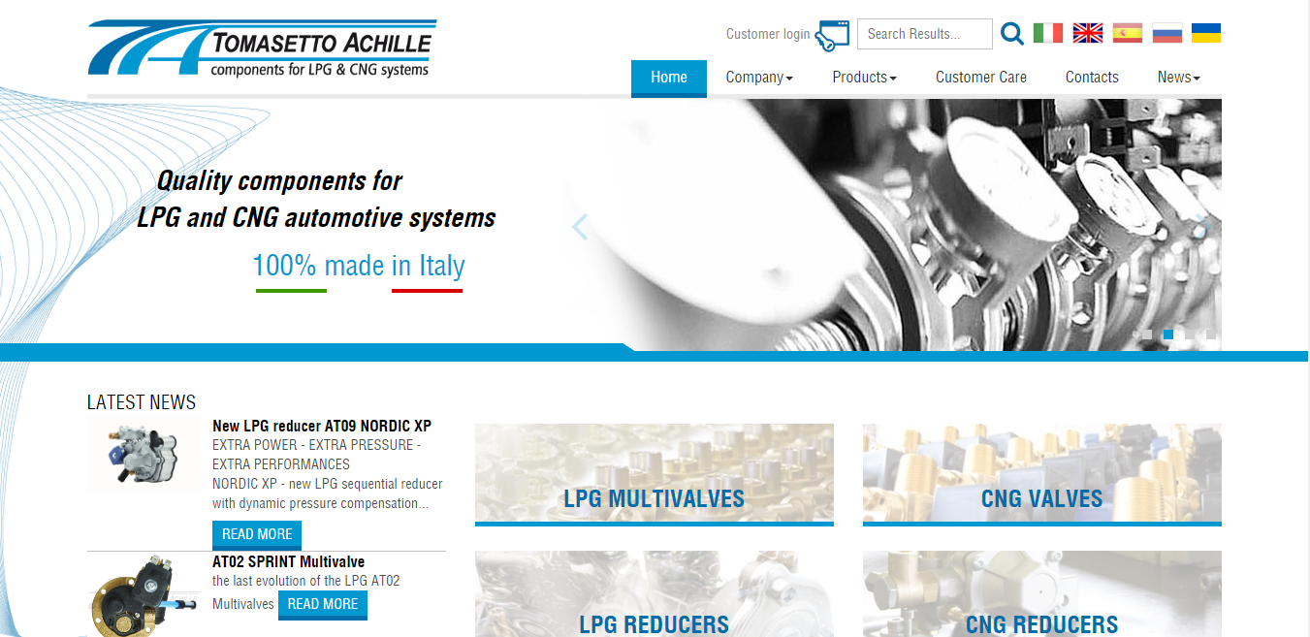

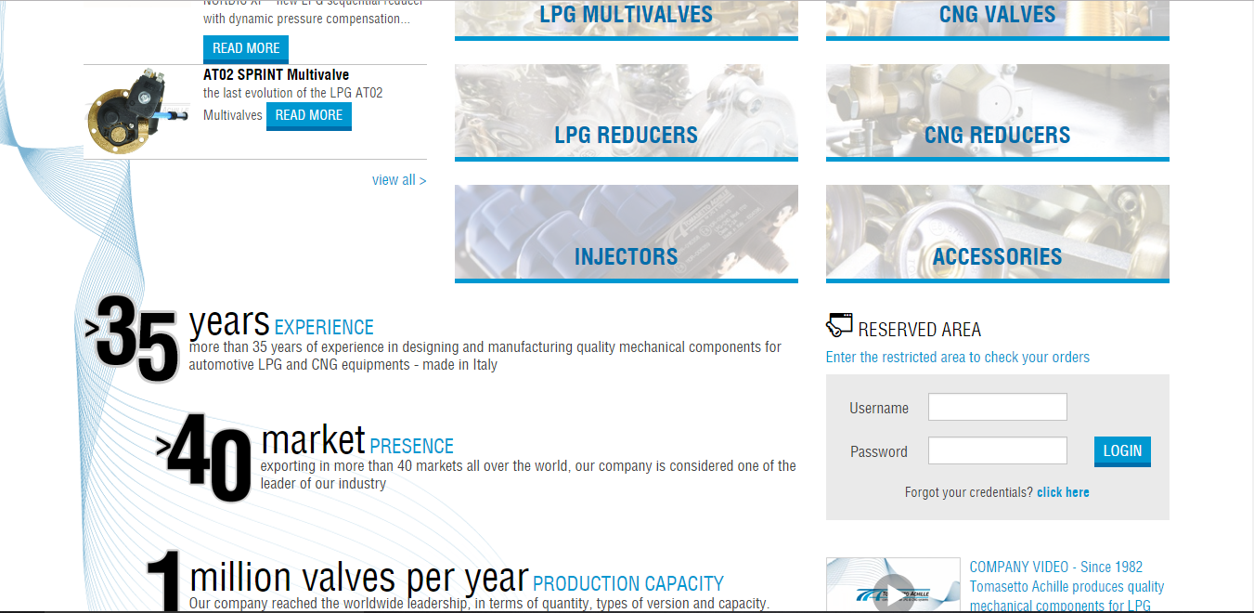

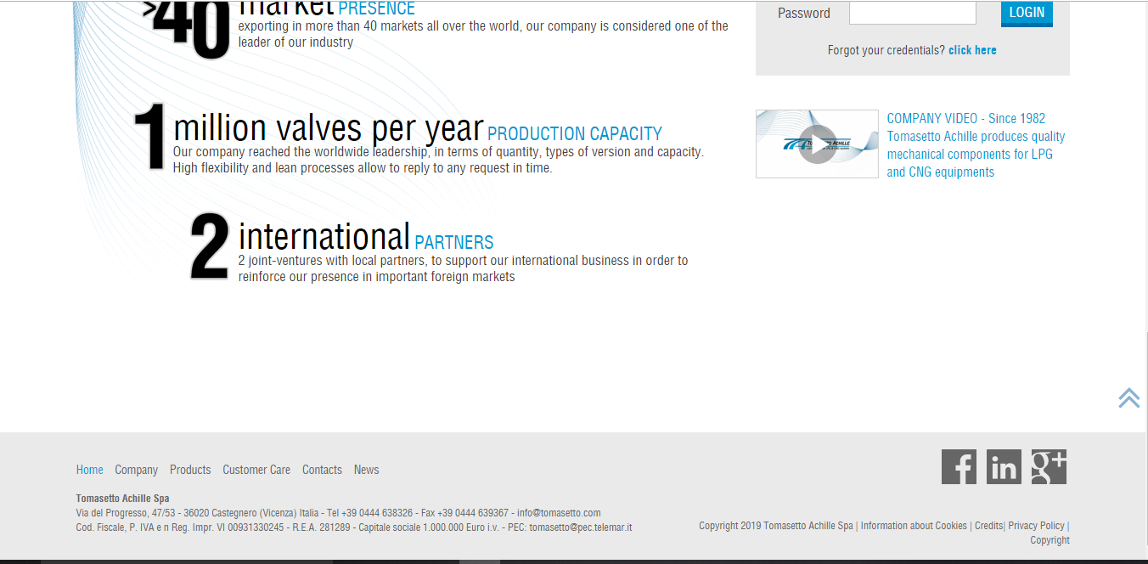

**COST:**

Not given

**DESIGN:**

DESIGN AND DEVELOPED BY **WEB AGENCY BY TELEMAR**

# ANALYSIS AND DESIGN

THE SOLUTION we have proposed for the problem which is faced by energy zone anticipating design and maintain the data to solve the require problem which were describe and we have provide the solution in our design project which consist of

1. **CNG department**
2. **The Vendor and Retailer department**
3. **Service Employee**
4. **Stock House**
5. **Finance Department**

**Analysis Use Case Documentation:**

In this we describe all diagrams including work flow, context, object, class, sequence, component and deployment diagram for the analyzing and implement our project.

**Business process workflow:**

As showing in figure 1 and figure 2.

**Business document workflow:**

As describe in figure 1 and figure 2.

**Context Diagram:**

As showing describe in figure 3.

**Object diagram:**

In this we describe the overall object diagrams of our organization.

**PURCHASE AND SERVICES:**

In this we describe **PURCHASE AND SERVICES** object diagram of our organization.

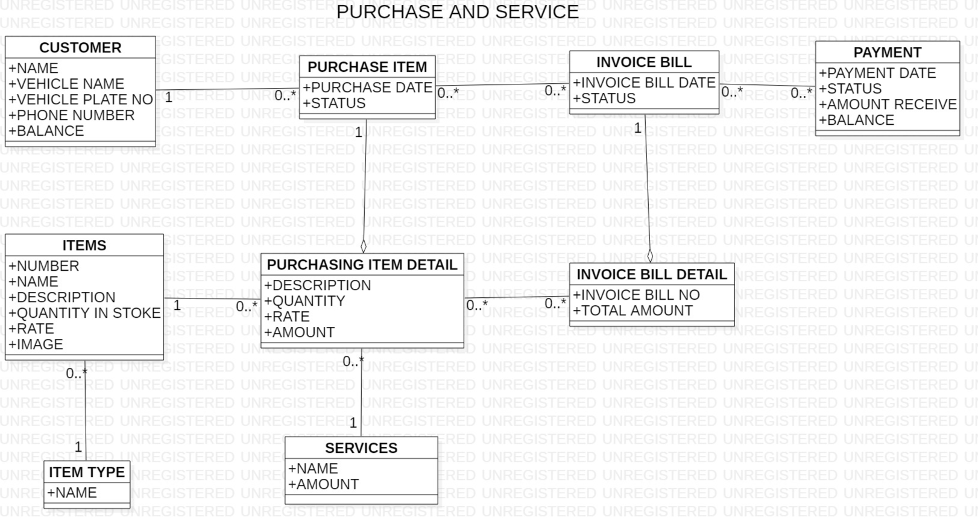

Figure OBJECT DIAGRAM PURCHASE AND SERVICE

In **Figure 4** we have following players:

1. Participant=Customer
2. Transaction=Purchase item
3. Transaction line item= Purchase item detail
4. Service (other associate of Purchase item detail )
5. Item
6. Item Type (other associate of item)
7. Subsequent transaction=Invoice bill & payment
8. Subsequent transaction line item =Invoice bill detail

In **Figure 4** customer has 1 is to many relationship with purchase item because 1 customer purchase many items same as with items & purchasing item detail. Purchase item has many to many relationship with invoice bill because many purchase item has many invoice bill same as with payment & invoice bill. Items has other associate with item type occur one is to many relationship because 1 item type has many items same as with service & purchasing items detail. In this purchasing items has aggregate relationship with purchasing item detail also invoice bill with invoice bill detail.

**SALES ORDER:**

In this we describe **SALES OREDR** object diagram of our organization.

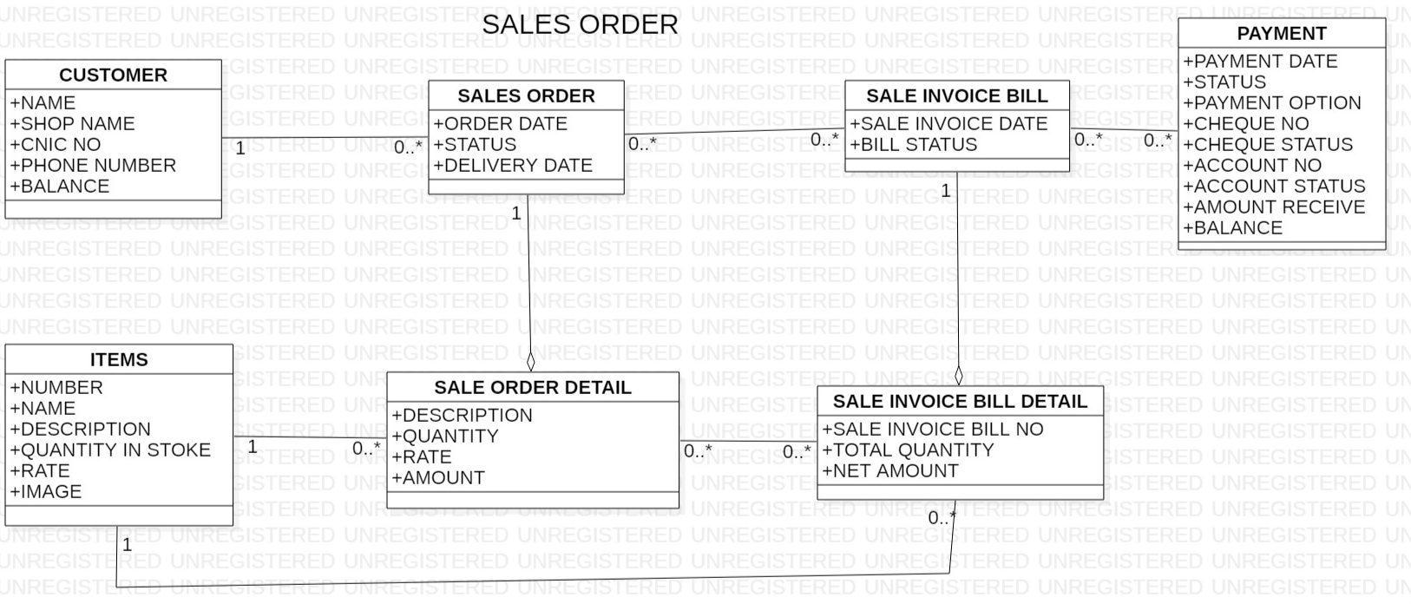

Figure OBJECT DIAGRAM SALE ORDER

In **Figure 5** we have following players:

1. Participant=Customer
2. Transaction=Sale order
3. Transaction line item= Sale order detail
4. Item
5. Invoice bill detail(Other associate of item)
6. Subsequent transaction=Invoice bill & payment
7. Subsequent transaction line item =Invoice bill detail

In **Figure 5** customer has 1 is to many relationship with sale order because 1 customer has many sale order same as with items & sale order detail. Sale order has many to many relationship with sale invoice bill because many Sale order has many sale invoice bill same as with payment & sale invoice bill. Sale invoice bill detail has other associate with items because 1 item has many sale invoice bill detail. In this sale order has aggregate relationship with sale order detail also sale invoice bill with sale invoice bill detail.

**VENDOR ORDER:**

In this we describe **VENDOR ORDER** object diagram of our organization.

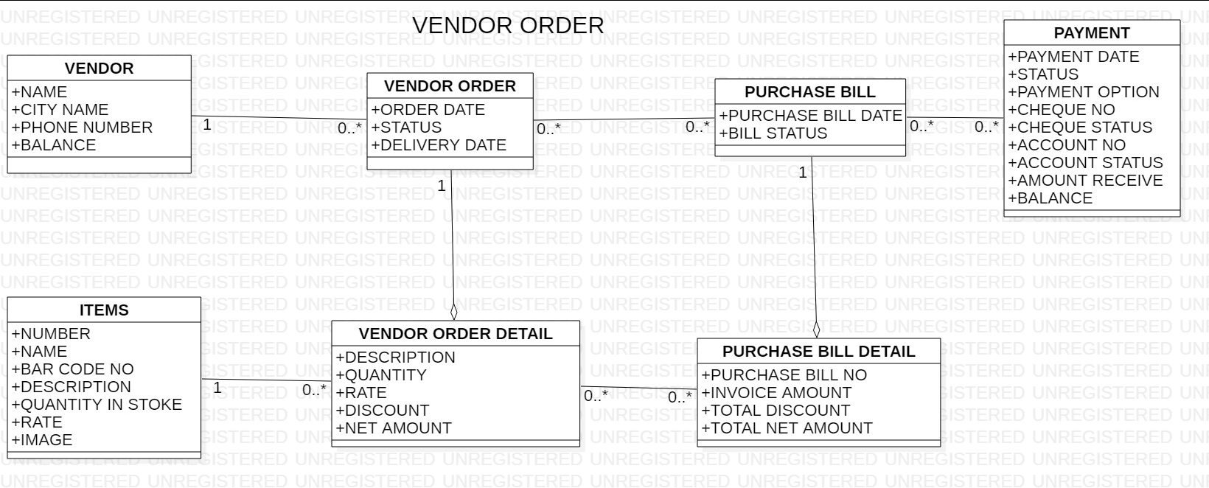

Figure OBJECT DIAGRAM VENDOR ORDER

In **Figure 6** we have following players:

1. Participant=Customer
2. Transaction=Vendor order
3. Transaction line item= Vendor order detail
4. Item
5. Subsequent transaction=Purchase bill & payment
6. Subsequent transaction line item = Purchase bill detail

In **Figure 6** vendor has 1 to many relationship with vendor order because 1 vendor has many vendor order same as with items & vendor order detail. Vendor order has many to many relationship with purchase bill because many vendor order has many purchase bill same as with payment & purchase bill. Purchase bill has other associate with items because 1 item has many sale invoice bill detail. In this vendor order has aggregate relationship with vendor order detail also purchase bill with purchase bill detail.

**Actor use case diagram:**

In this we describe **the actor use case** diagram of our organization.

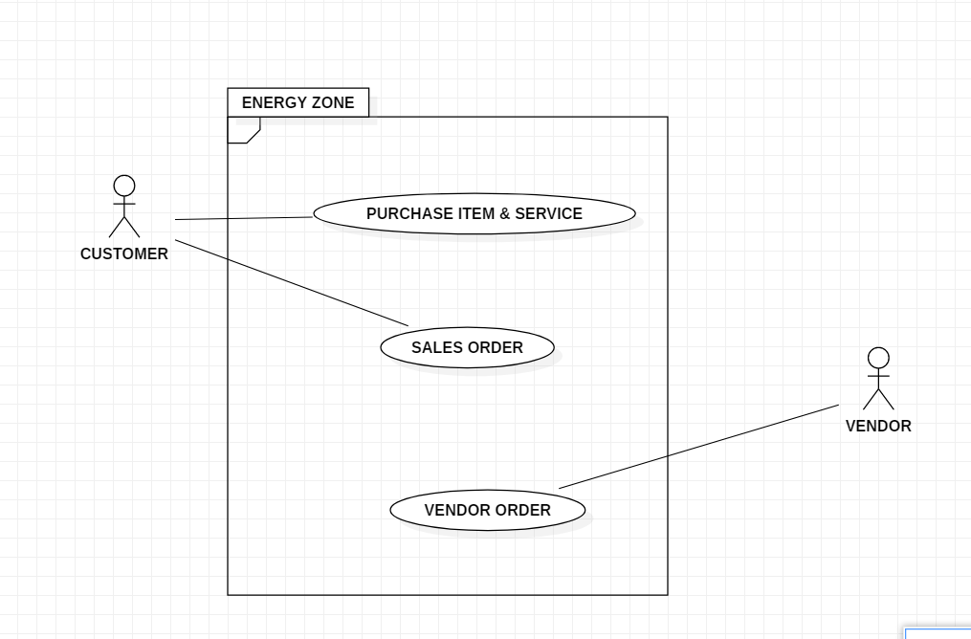

Figure ACTOR USE CASE OF ENERGYZONE

In **figure 7** we have actor use case diagram we describe the process which done by primary actor or first step taking person in which customer do purchase items and use the service of our shop also buying large quantity amount of items which we called sales order of the customer. On the other way vendor is deliver of our shop purchasing order due to this he acts as primary actor in our energy zone shop.

**Actor use case table**

|  |  |  |  |  |
| --- | --- | --- | --- | --- |
| Usecase | **PRIMARY ACTOR** | system actor | other participating actor | other interested stakeholder |
| PURCHASE & SERVICES | CUSTOMER | OWNER | SERVICE EMPLOYEE | FINANCE PERSON |
| SALES ORDER | CUSTOMER | OWNER | SERVICE EMPLOYEE | FINANCE PERSON |
| VENDOR ORDER | VENDOR | OWNER | SERVICE EMPLOYEE | FINANCE PERSON |

Table ACTOR USE CASE

**Report list Table**

|  |  |  |  |  |  |  |  |
| --- | --- | --- | --- | --- | --- | --- | --- |
| **USECASE NAME** | **TYPE** | **SUBTYPE** | **MEDIA** | **FREQUENCY** | **PAGE** | **NO OF SHEETS** | **NO OF COPIES** |
| **Purchase & Services** | **Interface**  **Entity** | **Detailed:**  List of all customers  **.Summary:**  Invoice bill | **Printer** | **Daily**  **On Customer purchase** | **A4** | **1**  **1** | **1**  **1** |
| **Sales Order** | **Interface**  **Entity** | **Detailed :** List of all customers  **.Summary:**  Sales invoice bill | **Printer** | **Daily**  **On Customer order purchase** | **A4** | **1**  **1** | **1**  **1** |
| **Vendor Order** | **Interface**  **Entity** | **Detailed :**  List of all vendors, List of all items purchase  **.Summary:**  Purchase bill | **Printer** | **Daily**  **On Vendor order occur** | **A4** | **1**  **1** | **1**  **1** |

Table REPORT LIST TABLE

## **PURCHASE ITEM & SERVICE**

### **Anal****ysis Use case documentation (A)**

Analysis use case document are as under:

|  |  |  |  |
| --- | --- | --- | --- |
| **USE CASE NAME:** | PURCHASE ITEM & SERVICE | | **USE CASE TYPE** |
| **USE CASE ID:** | PI-018 | | Business Requirements: **🞏** |
| **PRIORITY:** | HIGH | | System Analysis: 🗹 |
| **SOURCE:** |  | |  |
| **PRIMARY BUSINESS ACTOR** | CUSTOMER | | |
| **PRIMARY SYSTEM ACTOR** | OWNER | | |
| **OTHER PARTICIPATING ACTORS:** | * OWNER | | |
| **OTHER INTERESTED STAKEHOLDERS:** |  | | |
| **DESCRIPTION:** | The use case describes the event when the Customer arrives at the shop for purchase some items not using the services. Once the purchasing is completed and he will be given invoice bill in which there is a bill no, date and the price of the item which he has pay to the Owner by completion of a purchase. | | |
| **PRE-CONDITION:** | The customer has to buy the items he needs it. | | |
| **TRIGGER:** | This use case is initiated when retailer require to purchase some item. | | |
| **TYPICAL COURSE** | **Actor Action** | **System Response** | |
| **OF EVENTS:** | **Step 1**: The customer arrives at the shop ask about the item which want to purchase it. | **Step 2**: The owner verifies the requirement of the item which retailer need it. | |
|  | **Step 3:** The customer viewing the items to check whether the item is exactly wanted by him. | **Step 4:** After customer verifies the itemsthe owner then adds the item to the invoice bill and service of then generated bill given to the customer. | |
|  | **Step 5:** The customer pay the invoice bill payment through Cash. | **Step 6:** The owner records the information of the Bill no, and Date of the purchasing item of retailer with amount through software. | |
| **ALTERNATE COURSES:** | **Alt Step 1:** The customer calls the owner ask about the item which want to purchase it then **step 3** follows. | | |
|  | **Alt Step 5:** The customer pay the invoice bill payment through Cheque and account no when purchasing items has high cost. | | |
| **CONCLUSION:** | The use case concludes when the customer gets the items he needs. | | |
| **POST-CONDITION:** | The purchasing record is saved to the system software. | | |
| **BUSINESS RULES** | * Customer have the need to buy the items. * There is no bargaining. * There is a limit of discount. | | |
| **IMPLEMENTATION CONTRAINTS AND SPECIFICATIONS** | * The Use Case is available when the shop is open. * It is estimated that these use cases are avail 15 to 20 times max a day. | | |
| **ASSUMPTIONS:** | * If all purchase items are not available customer has to return back. | | |
| **OPEN ISSUES:** | None | | |

### **Design Use case Documentation (D):**

Design use case document are as under:

|  |  |  |  |
| --- | --- | --- | --- |
| **USE CASE NAME:** | PURCHASE ITEM & SERVICE | | **USE CASE TYPE** |
| **USE CASE ID:** | PI-018 | | Business Requirements: **🞏** |
| **PRIORITY:** | HIGH | | System Analysis: 🞏 |
| **SOURCE:** |  | | System Design: 🗹 |
| **PRIMARY BUSINESS ACTOR** | CUSTOMER | | |
| **PRIMARY SYSTEM ACTOR** | OWNER | | |
| **OTHER PARTICIPATING ACTORS:** | * OWNER | | |
| **OTHER INTERESTED STAKEHOLDERS:** |  | | |
| **DESCRIPTION:** | The use case describes the event when the Customer arrives at the shop for purchase some items not using the services. Once the purchasing is completed and he will be given invoice bill in which there is a bill no, date and the price of the item which he has pay to the Owner by completion of a purchase. | | |
| **PRE-CONDITION:** | The customer has to buy the items he needs it. | | |
| **TRIGGER:** | This use case is initiated when retailer require to purchase some item. | | |
| **TYPICAL COURSE** | **Actor Action** | **System Response** | |
| **OF EVENTS:** | **Step 1**: The owner selects the customer through combo box and select the items, service and fill the quantity of items in the purchase item info interface. Then clicks the save button. | **Step 2**: The system respond by loading all information of customer and item and show all the purchasing detail in grid box record in the database. | |
|  | **Step 3:** Then owner clicks the next button then opens invoice bill info then he selects the customer then fill invoice bill no with date and net amount then select the status by radio button the click save button. | **Step 4:** The system respond by record the information in database and show in the grid and invoice bill box. | |
|  | **Step 5:** Then owner clicks the next button then open invoice payment then he selects the customer and fill date, invoice bill no, status of bill and payment and amount received then click the add payment. | **Step 6:** The system load the total amount and balance in their respective box and show all necessary information into the grid box. | |
| **ALTERNATE COURSES:** | **Alt Step 1:** If customer not in the combo box then owner click new customer then add the customer in customer registration interface. Also update, delete, search and get the list the customer there. | | |
|  | **Alt Step 1:** If owner want to search the customer info by enter name into search textbox. | | |
|  | **Alt Step 3:** If owner want to search the customer bill info by enter name into search textbox. | | |
|  | **Alt Step 5:** If owner want to delete a payment the fill the id in textbox the clicks delete. Also owner update the payment of the customer by click update button. | | |
| **CONCLUSION:** | The use case concludes when the customer gets the items he needs. | | |
| **POST-CONDITION:** | The purchasing record is saved to the system software. | | |
| **BUSINESS RULES** | * Customer have the need to buy the items. * There is no bargaining. * There is a limit of discount. | | |
| **IMPLEMENTATION CONTRAINTS AND SPECIFICATIONS** | * The Use Case is available when the shop is open. * It is estimated that these use cases are avail 15 to 20 times max a day. | | |
| **ASSUMPTIONS:** | * If all purchase items are not available customer has to return back. | | |
| **OPEN ISSUES:** | None | | |

### **Sequence Diagram (D):**

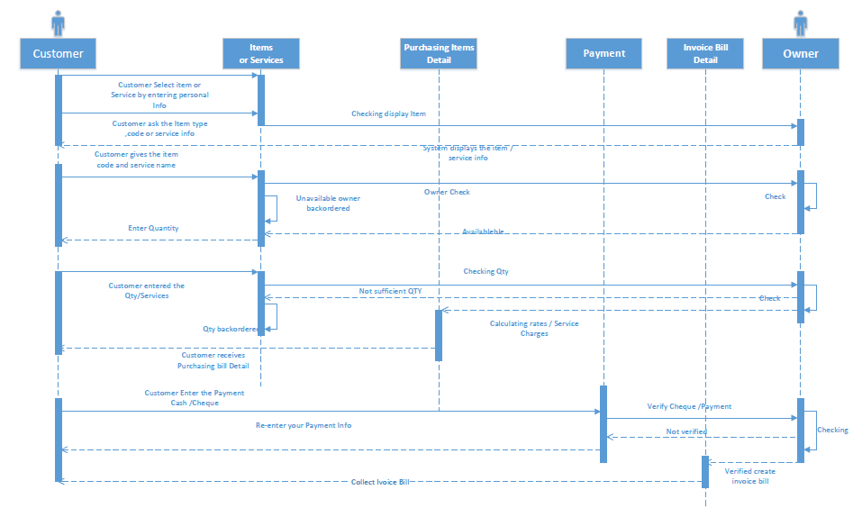

Figure SEQUENCE DIAGRAM OF PURCHASE & SERVICE

### **Input Design Prototype (D):**

These are the input design prototype of this use case

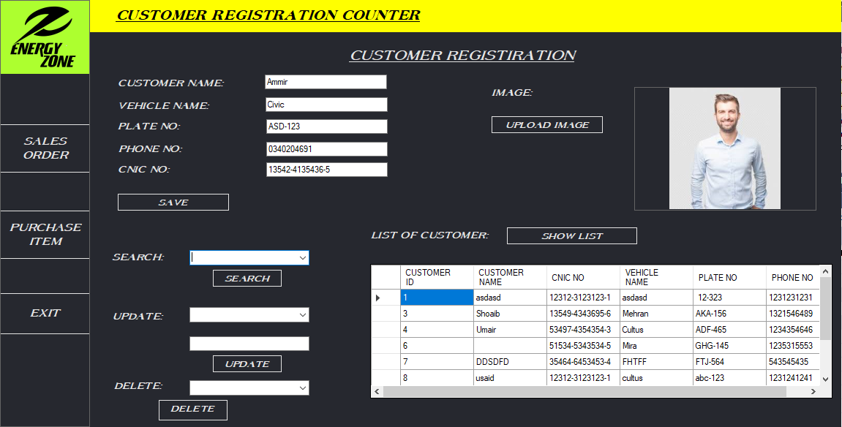

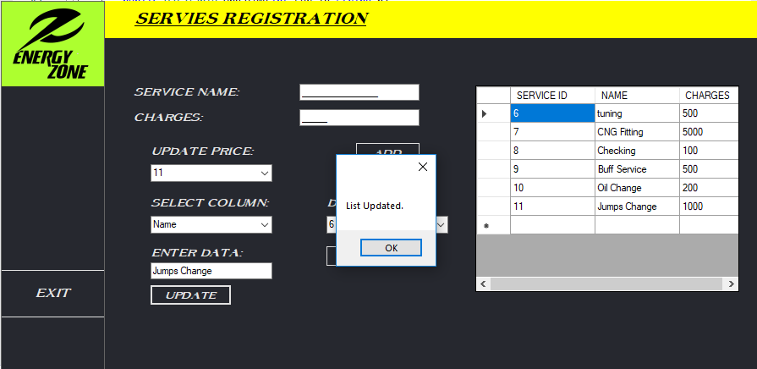

### **Output Design Prototype (D):**

These are the input design prototype of this use case

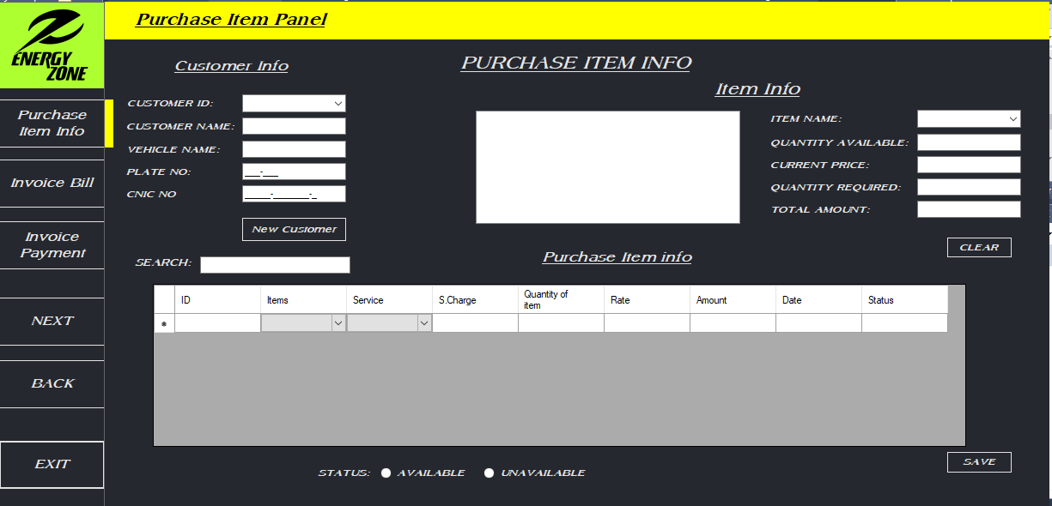

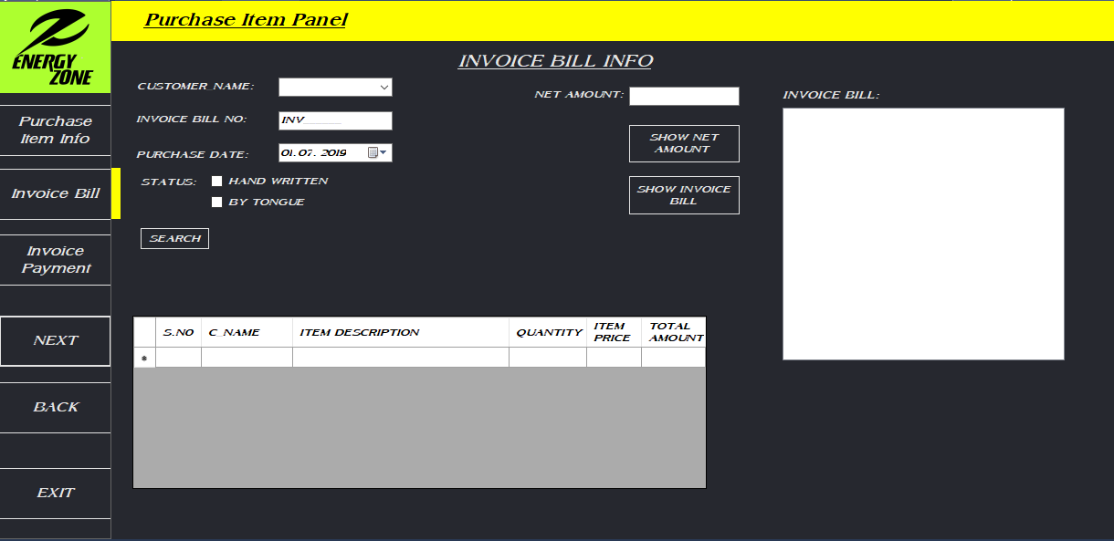

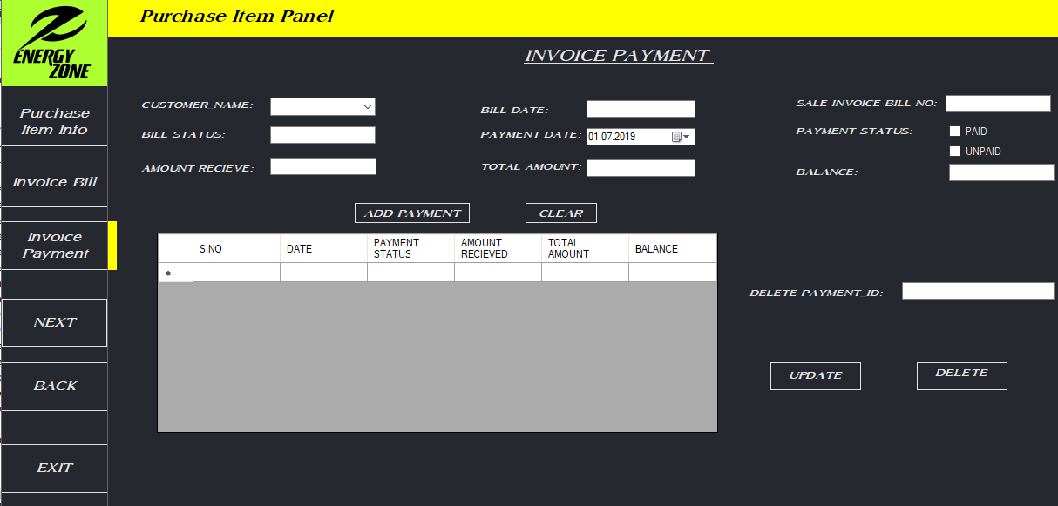

### **Class diagram (D):**

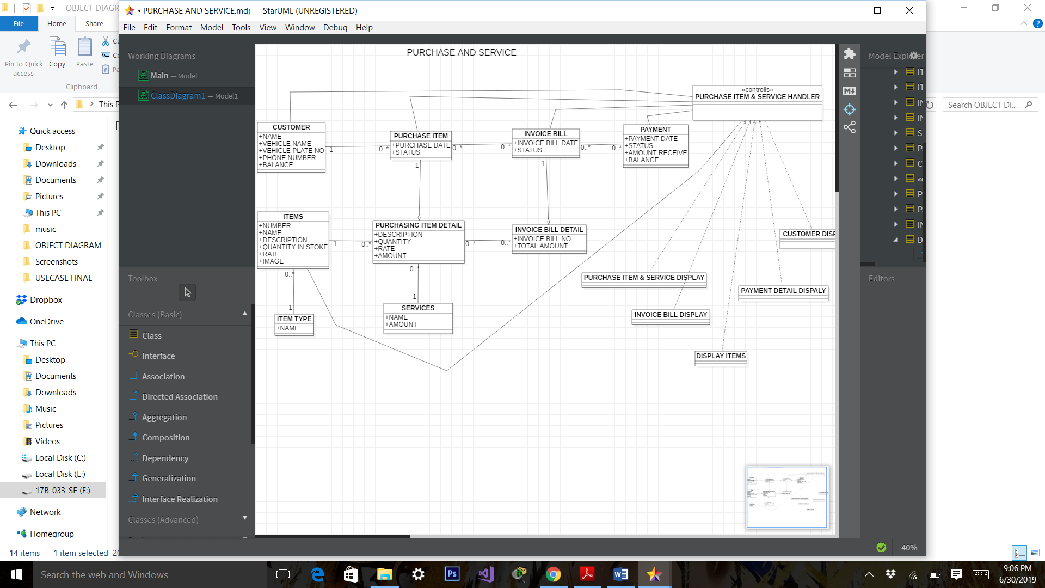

Figure CLASS DIAGRAM OF PURCHASE & SERVICE

## **SALES ORDER**

### **Analysis Use case documentation (A)**

Analysis use case document are as under:

|  |  |  |  |
| --- | --- | --- | --- |
| **USE CASE NAME:** | SALE ORDER | | **USE CASE TYPE** |
| **USE CASE ID:** | SO-014 | | Business Requirements: **🞏** |
| **PRIORITY:** | HIGH | | System Analysis: 🗹 |
| **SOURCE:** |  | |  |
| **PRIMARY BUSINESS ACTOR** | Customer | | |
| **PRIMARY SYSTEM ACTOR** | OWNER | | |
| **OTHER PARTICIPATING ACTORS:** | * OWNER * FINANCE PERSON | | |
| **OTHER INTERESTED STAKEHOLDERS:** |  | | |
| **DESCRIPTION:** | The use case describes the event when the Customer arrives at the shop or calling the owner to give the sale order. Once the purchasing order is completed, finance person give the invoice bill to customer then payment is done. | | |
| **PRE-CONDITION:** | The Customer has to purchase the items he ordered it. | | |
| **TRIGGER:** | This use case is initiated when the customer gives the sales Order. | | |
| **TYPICAL COURSE** | **Actor Action** | **System Response** | |
| **OF EVENTS:** | **Step 1**: The Customer arrives at the shop to give the sales order. | **Step 2**: The owner responds by taking the information of customer and verifies the stock. | |
|  | **Step 3:** Once verification is done the customer ask about the bill. | **Step 4:** The owner gives the invoice bill to the customer informs him three types of payment (Cash, Cheque and Via account number or online) | |
|  | **Step 5** The Customer pays the invoice bill payment by using one of the method ways. | **Step 6:** The owner records the information of the Purchasing Order detail including, Bill no, Date time, items description and its quantity, rate and amount. | |
| **ALTERNATE COURSES:** | **Alt Step 1:** Customer calling the owner to give the purchasing order. | | |
| **CONCLUSION:** | The use case concludes when the Customer gets the Order he needs. | | |
| **POST-CONDITION:** | The purchasing Order details record is saved to the system software. | | |
| **BUSINESS RULES** | * Customer have the need to purchase the items through given order. * There is no bargaining. * There is a limit of discount. | | |
| **IMPLEMENTATION CONTRAINTS AND SPECIFICATIONS** | * The Use Case is available when the shop is open. * It occurs when there is possibility of purchasing | | |
| **ASSUMPTIONS:** | * If all purchase Order is not available Customer has to return back. | | |
| **OPEN ISSUES:** | None | | |

### **Design Use case Documentation (D):**

Design use case document are as under:

|  |  |  |  |
| --- | --- | --- | --- |
| **USE CASE NAME:** | SALE ORDER | **USE CASE TYPE** | |
| **USE CASE ID:** | SO-014 | Business Requirements: **🞏** | |
| **PRIORITY:** | HIGH | System Analysis: 🞏 | |
| **SOURCE:** |  | System Design: 🗹 | |
| **PRIMARY BUSINESS ACTOR** | Customer | | |
| **PRIMARY SYSTEM ACTOR** | OWNER | | |
| **OTHER PARTICIPATING ACTORS:** | * OWNER * FINANCE PERSON | | |
| **OTHER INTERESTED STAKEHOLDERS:** |  | | |
| **DESCRIPTION:** | The use case describes the event when the Customer arrives at the shop or calling the owner to give the sale order. Once the purchasing order is completed, finance person give the invoice bill to customer then payment is done. | | |
| **PRE-CONDITION:** | The Customer has to purchase the items he ordered it. | | |
| **TRIGGER:** | This use case is initiated when the customer gives the sales Order. | | |
| **TYPICAL COURSE** | **Actor Action** | | **System Response** |
| **OF EVENTS:** | **Step 1**: The owner selects the customer through combo box and select the items, service and fill the quantity of items, order date, delivery date and status in the sale ordder info interface. Then clicks the add transaction button. | | **Step 2**: The system respond by loading all information of customer and item and show all the sale order detail in grid box record in the database. |
|  | **Step 3:** Then owner clicks the next button then opens sale invoice bill info then he selects the customer then fill invoice bill no with date and net amount then select the status by radio button the click save button. | | **Step 4:** The system respond by record the information in database and show in the grid and invoice bill box. |
|  | **Step 5:** Then owner clicks the next button then open invoice payment then he selects the customer and fill date, invoice bill no, status of bill and payment , cheque and amount received then click the add payment. | | **Step 6:** The system load the total amount and balance in their respective box and show all necessary information into the grid box. |
| **ALTERNATE COURSES:** | **Alt Step 1:** If customer not in the combo box then owner click new customer then add the customer in customer registration interface. Also update, delete, search and get the list the customer there. | | |
|  | **Alt Step 1:** If owner want to search the customer info by enter name into search textbox. Same with delete transaction. | | |
|  | **Alt Step 3:** If owner want to search the customer bill info by enter name into search textbox. | | |
|  | **Alt Step 5:** If owner want to delete a payment the fill the id in textbox the clicks delete and all delete click all delete. Also owner update the payment of the customer by click update button. | | |
|  |  | | |
| **CONCLUSION:** | The use case concludes when the Customer gets the Order he needs. | | |
| **POST-CONDITION:** | The purchasing Order details record is saved to the system software. | | |
| **BUSINESS RULES** | * Customer have the need to purchase the items through given order. * There is no bargaining. * There is a limit of discount. | | |
| **IMPLEMENTATION CONTRAINTS AND SPECIFICATIONS** | * The Use Case is available when the shop is open. * It occurs when there is possibility of purchasing | | |
| **ASSUMPTIONS:** | * If all purchase Order is not available Customer has to return back. | | |
| **OPEN ISSUES:** | None | | |

### **Sequence Diagram (D):**

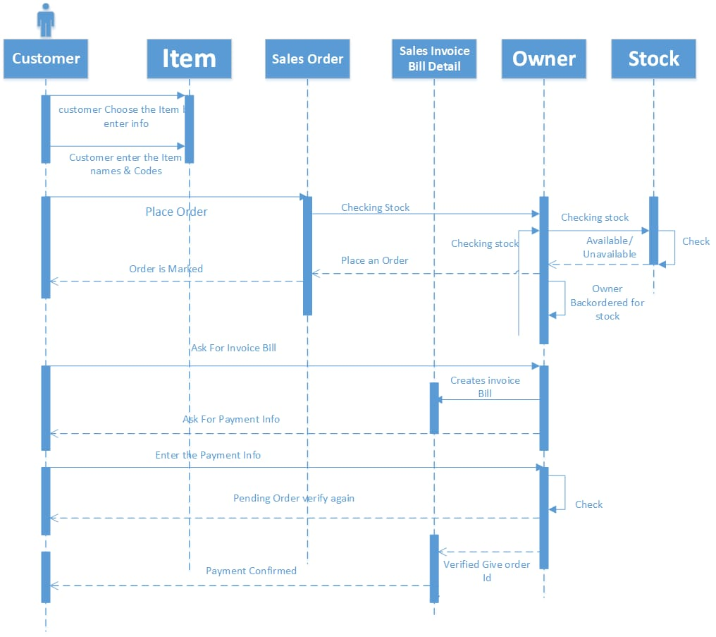

Figure SEQUENCE DIAGRAM OF SALES ORDER

### **Input Design Prototype (D):**

These are the input design prototype of this use case



### **Output Design Prototype (D):**

These are the output design prototype of this use case.

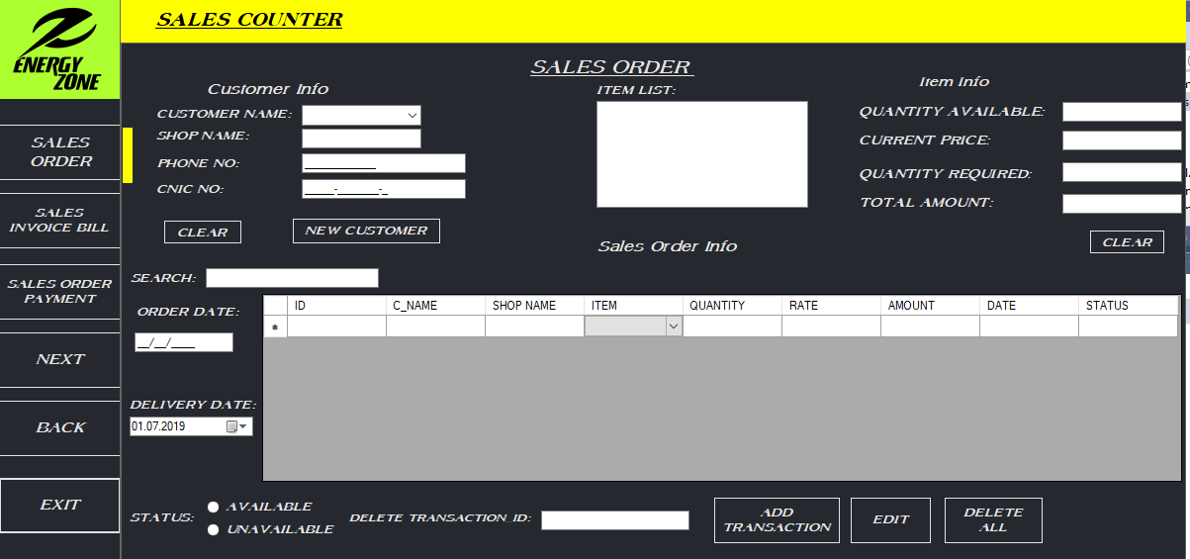 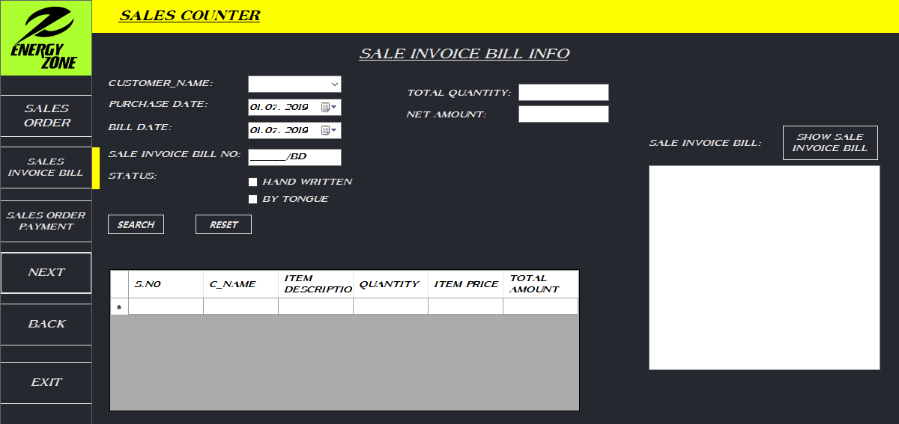

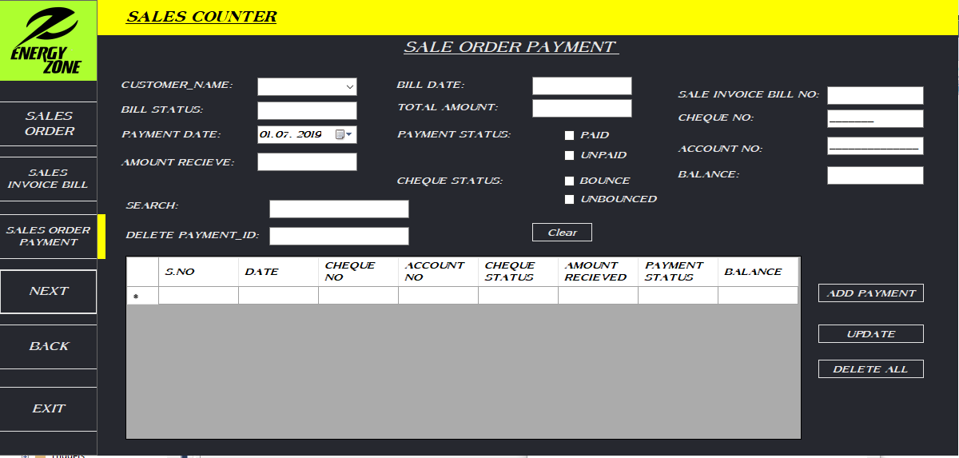

### **Class diagram (D):**

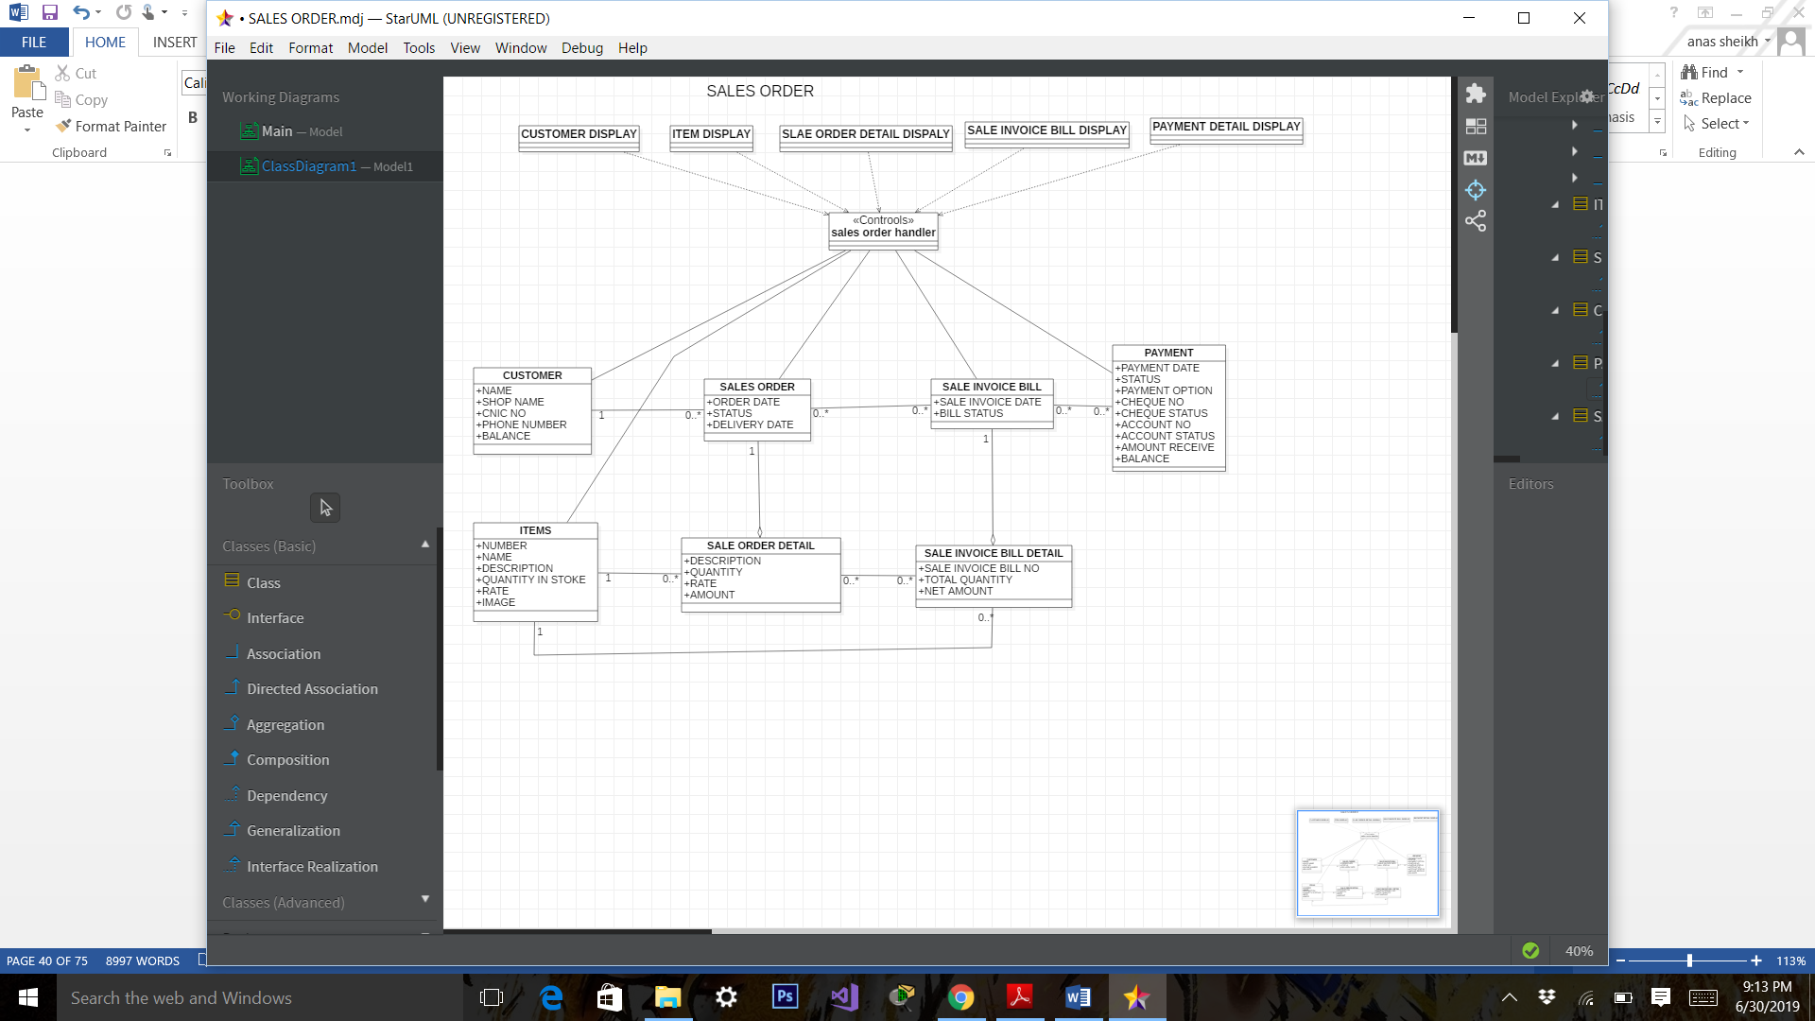

Figure CLASS DIAGRAM OF SALES ORDER

## **VENDOR ORDER**

### **Analysis Use case documentation (A)**

Analysis use case document are as under:

|  |  |  |  |
| --- | --- | --- | --- |
| **USE CASE NAME:** | VENDOR ORDER | | **USE CASE TYPE** |
| **USE CASE ID:** | VO-017 | | Business Requirements: **🞏** |
| **PRIORITY:** | HIGH | | System Analysis: 🗹 |
| **SOURCE:** |  | |  |
| **PRIMARY BUSINESS ACTOR** | OWNER | | |
| **PRIMARY SYSTEM ACTOR** | OWNER | | |
| **OTHER PARTICIPATING ACTORS:** | * FINANCE | | |
| **OTHER INTERESTED STAKEHOLDERS:** | * SERVICE EMPLOYEE | | |
| **DESCRIPTION:** | The use case evaluates the event when particular items in the stock is nearly finish which demand by the customer, owner give the order to Vendor for purchase the different items due to which requirement in the stock completed. When the order is delivered, finance person give payment of purchasing and enter the purchasing data in the web base application to make purchasing bill. | | |
| **PRE-CONDITION:** | Owner has to order vendor for purchasing items. | | |
| **TRIGGER:** | This Use Case is initiated that when particular items in the stock is nearly finish which demand by the customer. | | |
| **TYPICAL COURSE** | **Actor Action** | **System Response** | |
| **OF EVENTS:** | **Step 1**: Owner creates the list of ordered purchased Goods which are require to complete the stock of the shop. | **Step 3**: When the order delivered by vendor owner add it in the stock. | |
|  | **Step 2:** Owner give the order to vendor by checking the list of the required items. | **Step 5:** Owner record the information of vendor order in the form of purchasing bill and give the payment. | |
|  | **Step 4:** Owner Evaluates the purchased Goods to check every item are in good condition and working properly and finance person give the payment after this. |
| **ALTERNATE COURSES:** | **Alt Step 1:** Owner have the information of purchased Goods which are require to complete the stock of the shop and give the order on the bases of this information and go to **step 3**. | | |
| **Alt Step 4:** If some items don’t work properly and in bad condition then purchasing return occur done by the owner. | | |
| **CONCLUSION:** | The Use Case Concludes that the owners gets the Order to fulfill the requirement of the stock. | | |
| **POST-CONDITION:** | Vendor Order Record is saved in the system. | | |
| **BUSINESS RULES** | * Owner has to give correct Vendor Order. * The Order should be Clear and labeled. * Owner has to checkout it’s selected order. | | |
| **IMPLEMENTATION CONTRAINTS AND SPECIFICATIONS** | * The use Case is available when the shop is open. * It occurs when there is possibility of ordering. | | |
| **ASSUMPTIONS:** | * If there is missing of any order from selected list of order the charges will not considered in Payment of the purchasing goods. | | |
| **OPEN ISSUES:** | None | | |

### **Design Use case Documentation (D):**

Design use case document are as under:

|  |  |  |  |
| --- | --- | --- | --- |
| **USE CASE NAME:** | VENDOR ORDER | | **USE CASE TYPE** |
| **USE CASE ID:** | VO-017 | | Business Requirements: **🞏** |
| **PRIORITY:** | HIGH | | System Analysis: 🞏 |
| **SOURCE:** |  | | System Design: 🗹 |
| **PRIMARY BUSINESS ACTOR** | OWNER | | |
| **PRIMARY SYSTEM ACTOR** | OWNER | | |
| **OTHER PARTICIPATING ACTORS:** | * FINANCE | | |
| **OTHER INTERESTED STAKEHOLDERS:** | * SERVICE EMPLOYEE | | |
| **DESCRIPTION:** | The use case evaluates the event when particular items in the stock is nearly finish which demand by the customer, owner give the order to Vendor for purchase the different items due to which requirement in the stock completed. When the order is delivered, finance person give payment of purchasing and enter the purchasing data in the web base application to make purchasing bill. | | |
| **PRE-CONDITION:** | Owner has to order vendor for purchasing items. | | |
| **TRIGGER:** | This Use Case is initiated that when particular items in the stock is nearly finish which demand by the customer. | | |
| **TYPICAL COURSE** | **Actor Action** | **System Response** | |
| **OF EVENTS:** | **Step 1**: The owner selects the vendor through combo box and select the items, service and fill the quantity of items, order date, delivery date, quantity received and status in the vendor order info interface. Then clicks the add transaction button. | **Step 2**: The system respond by loading all information of vendor and item and show all the vendor order detail in grid box record in the database. | |
|  | **Step 3:** Then owner clicks the next button then opens purchase bill info then he selects the vendor then fill purchase bill no with date and net amount then select the status by radio button the click save button. | **Step 4:** The system respond by record the information in database and show in the grid and invoice bill box.  **Step 6:** The system load the total amount and balance in their respective box and show all necessary information into the grid box. | |
|  | **Step 5:** Then owner clicks the next button then open purchase bill payment then he selects the vendor and fill date, purchase bill no, status of bill and payment , cheque and amount paid then click the add payment. |
| **ALTERNATE COURSES:** | **Alt Step 1:** If vendor not in the combo box then owner click new customer then add the customer in customer registration interface. Also update, delete, search and get the list the customer there. Same as with item. | | |
| **Alt Step 1:** If owner want to search the vendor info by enter name into search textbox. Same with delete transaction. | | |
|  | **Alt Step 3:** If owner want to search the vendor bill info by enter name into search textbox. | | |
|  | **Alt Step 5:** If owner want to delete a payment the fill the id in textbox the clicks delete and all delete click all delete. Also owner update the payment of the vendor by click update button. | | |
| **CONCLUSION:** | The Use Case Concludes that the owners gets the Order to fulfill the requirement of the stock. | | |
| **POST-CONDITION:** | Vendor Order Record is saved in the system. | | |
| **BUSINESS RULES** | * Owner has to give correct Vendor Order. * The Order should be Clear and labeled. * Owner has to checkout it’s selected order. | | |
| **IMPLEMENTATION CONTRAINTS AND SPECIFICATIONS** | * The use Case is available when the shop is open. * It occurs when there is possibility of ordering. | | |
| **ASSUMPTIONS:** | * If there is missing of any order from selected list of order the charges will not considered in Payment of the purchasing goods. | | |
| **OPEN ISSUES:** | None | | |

### **Sequence Diagram (D)**

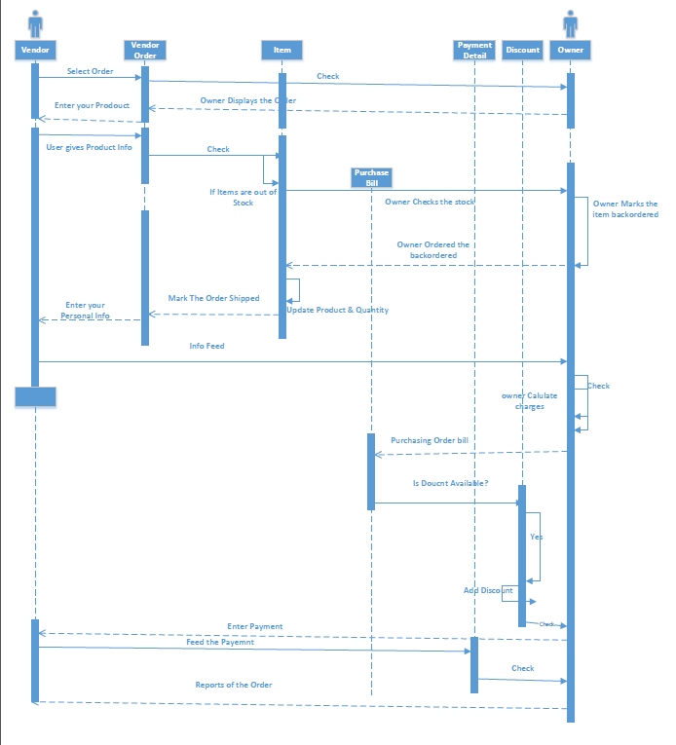

Figure SEQUENCE DIAGRAM OF VENDOR ORDER

### **Input Design Prototype (D):**

These are the input design prototype of this use case

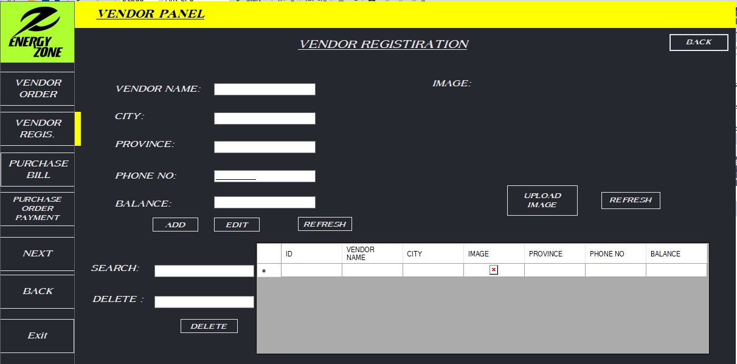

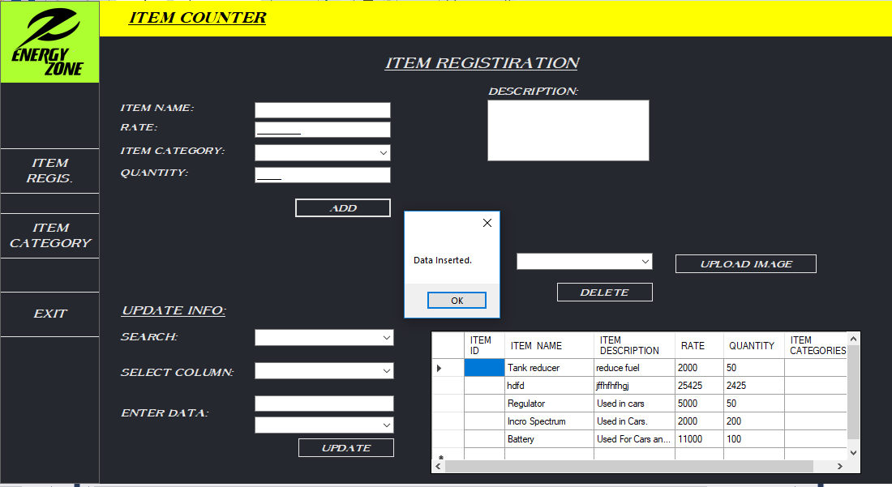

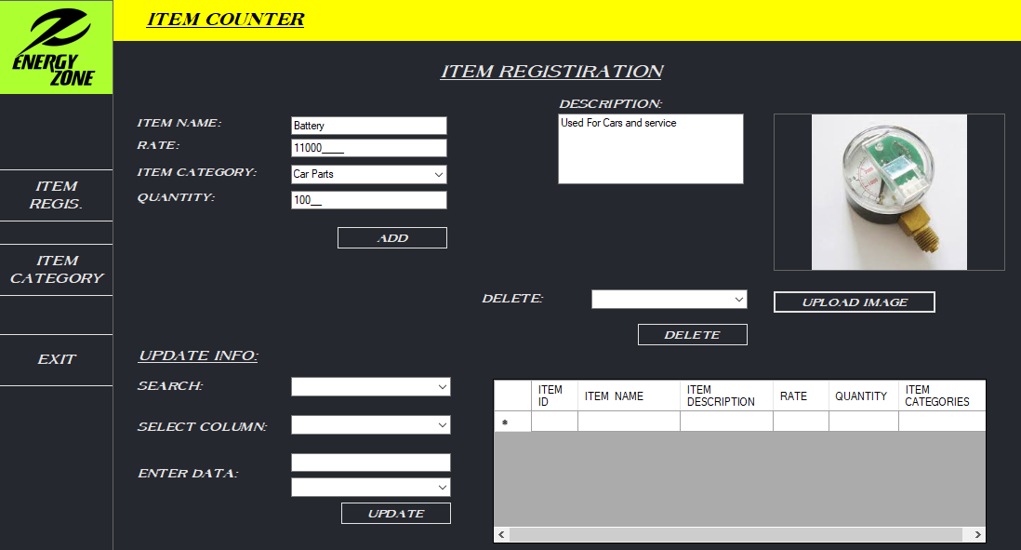

### **Output Design Prototype (D):**

These are the output design prototype of this use case.

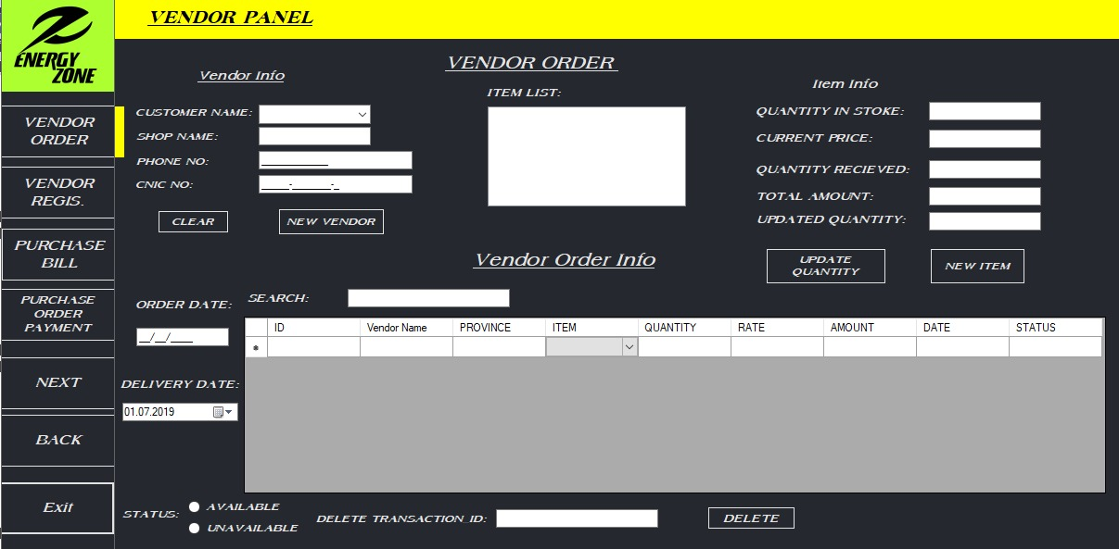

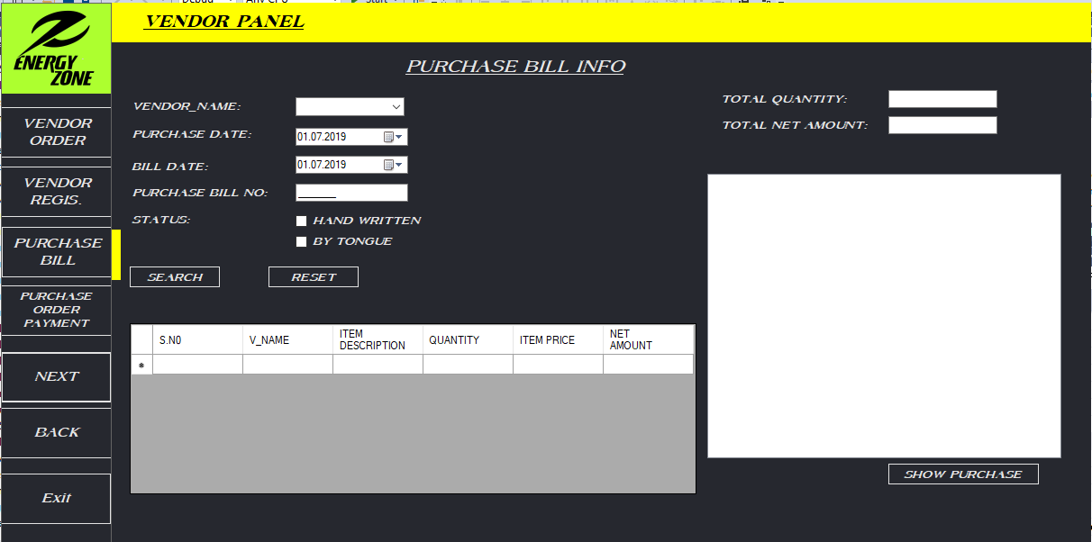

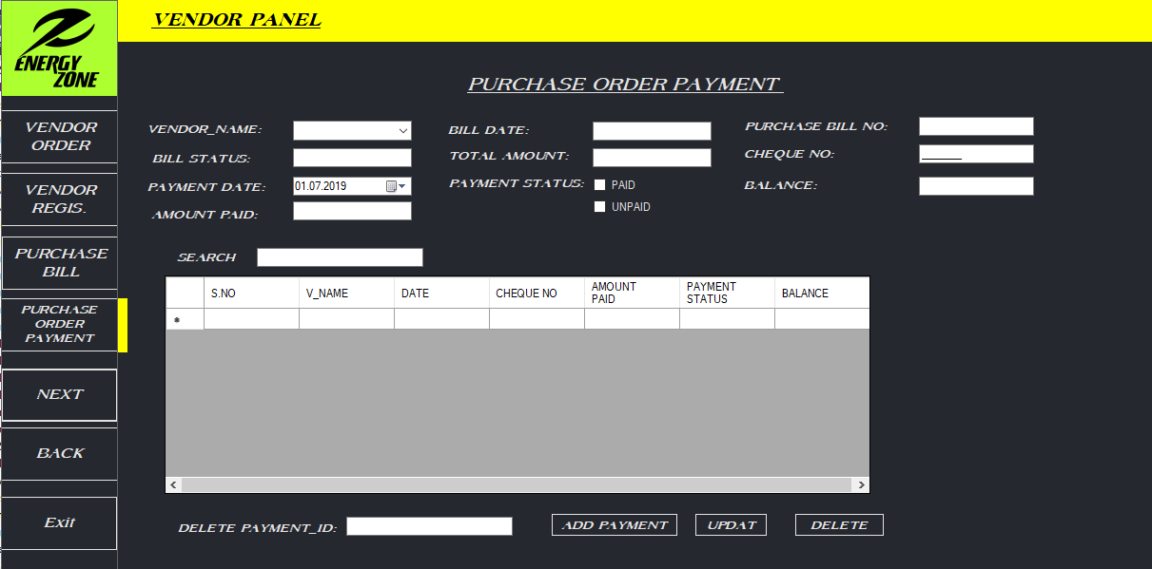

### **Class diagram (D):**

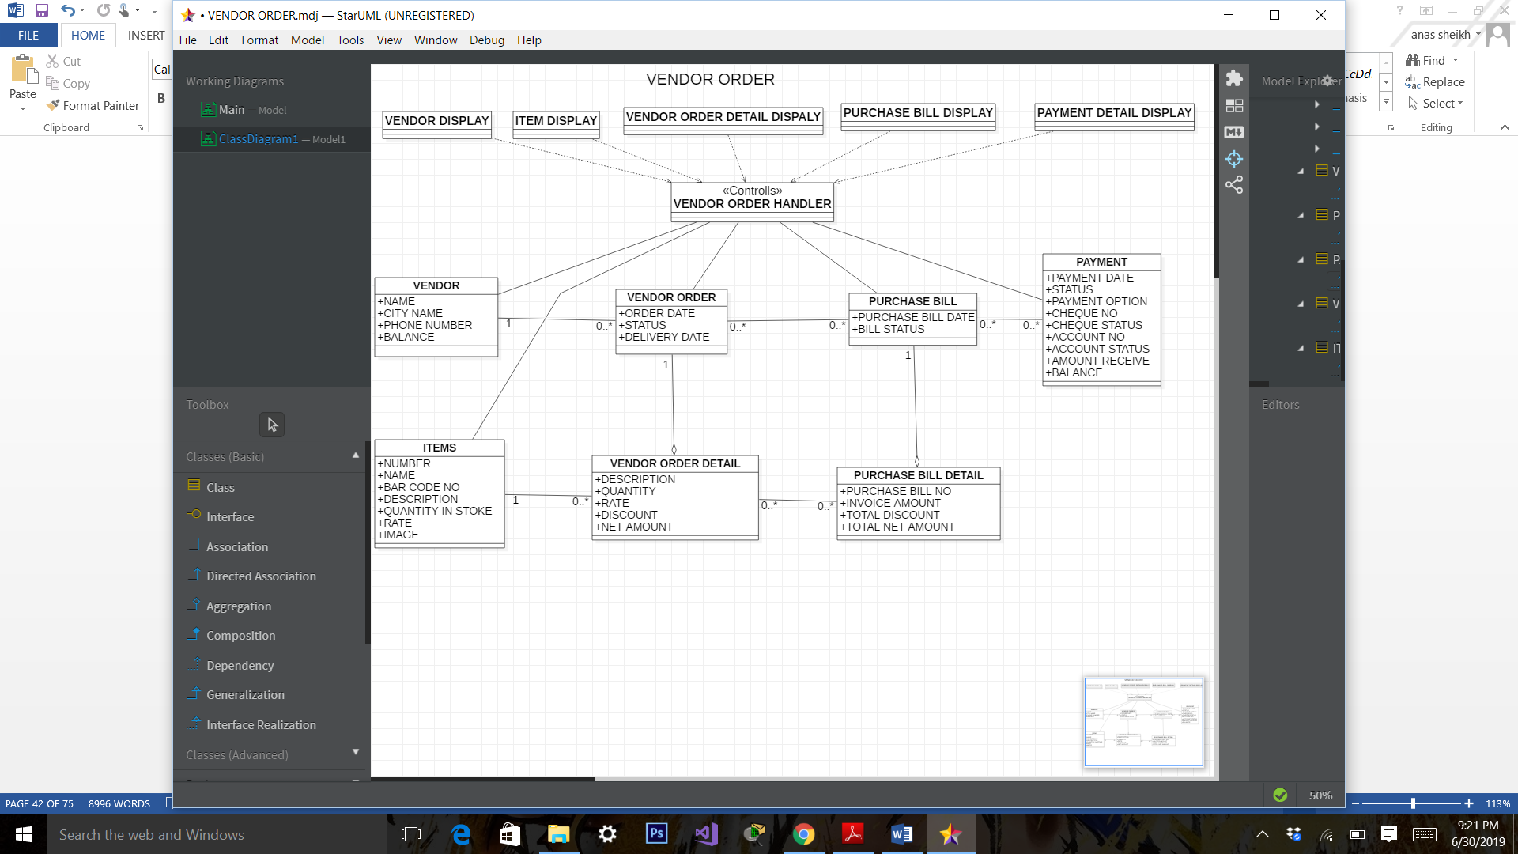

Figure CLASS DIAGRAM OF VENDOR ORDER

## **Database Diagram:**

In this we see the overall database diagrams of our organization.

**PURCHASE ITEM & SERVICE:**

In this we see the overall database diagrams of purchase item & service.

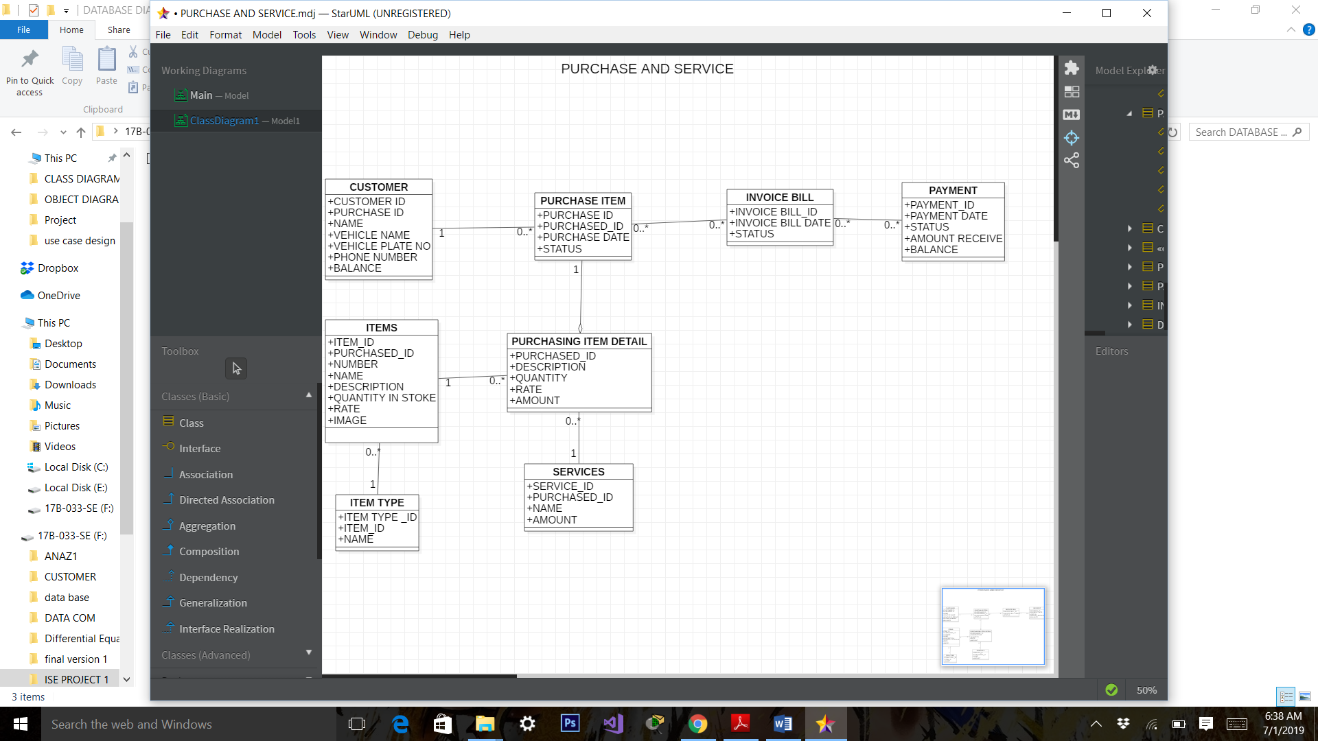

Figure DATABASE DIAGRAM OF PURCHASE ITEM

**SALES ORDER**

In this we see the overall database diagrams of sale order.

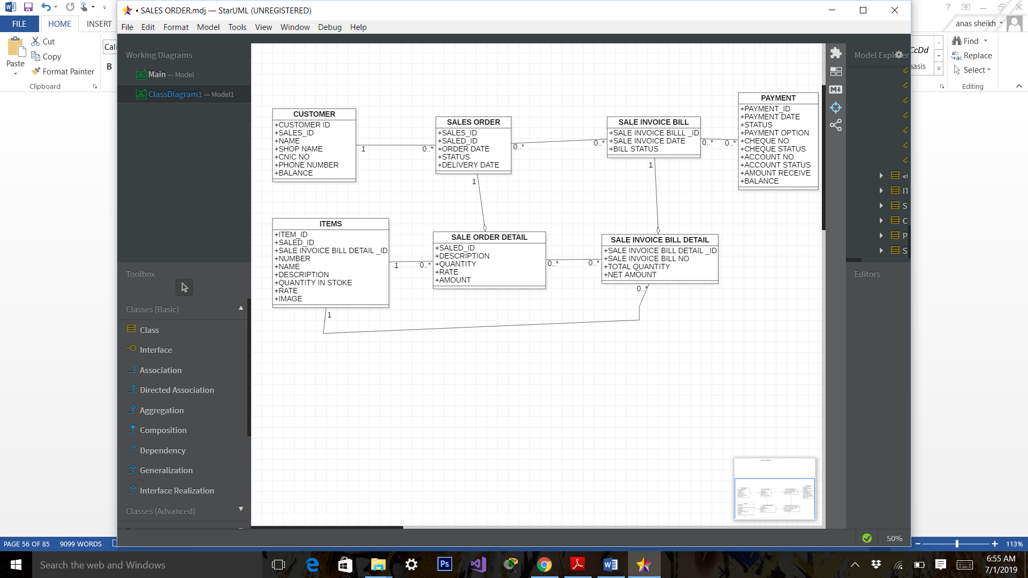

Figure DATABASE DIAGRAM OF SALES ORDER

**VENDOR ORDER**

In this we see the overall database diagrams of vendor order.

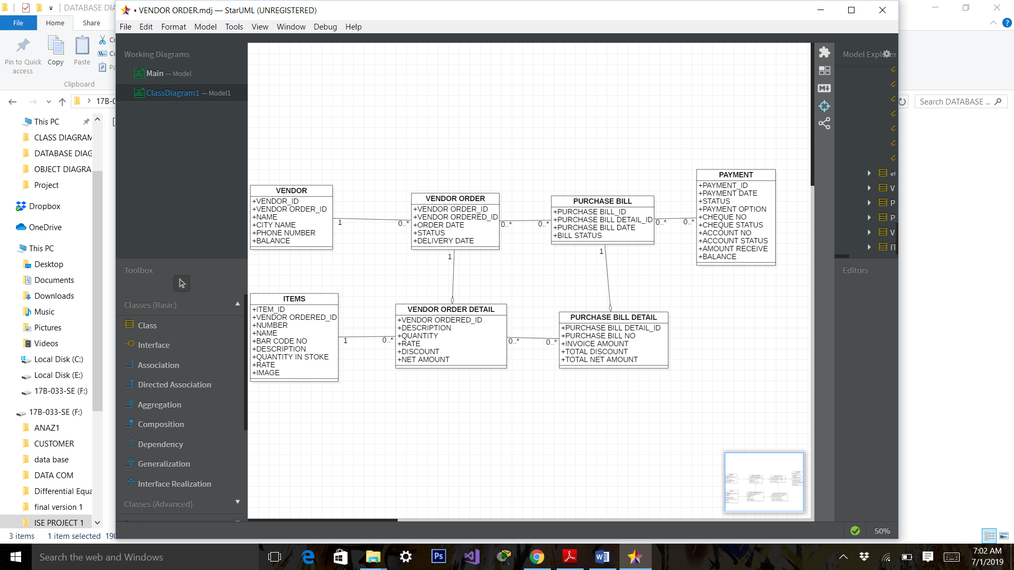

Figure DATABASE DIAGRAM OF VENDOR ORDER

# Implementation

In this we see the overall component & deployment diagram of our organization.

### **Component diagram:**

In this we see the component diagram of our organization.

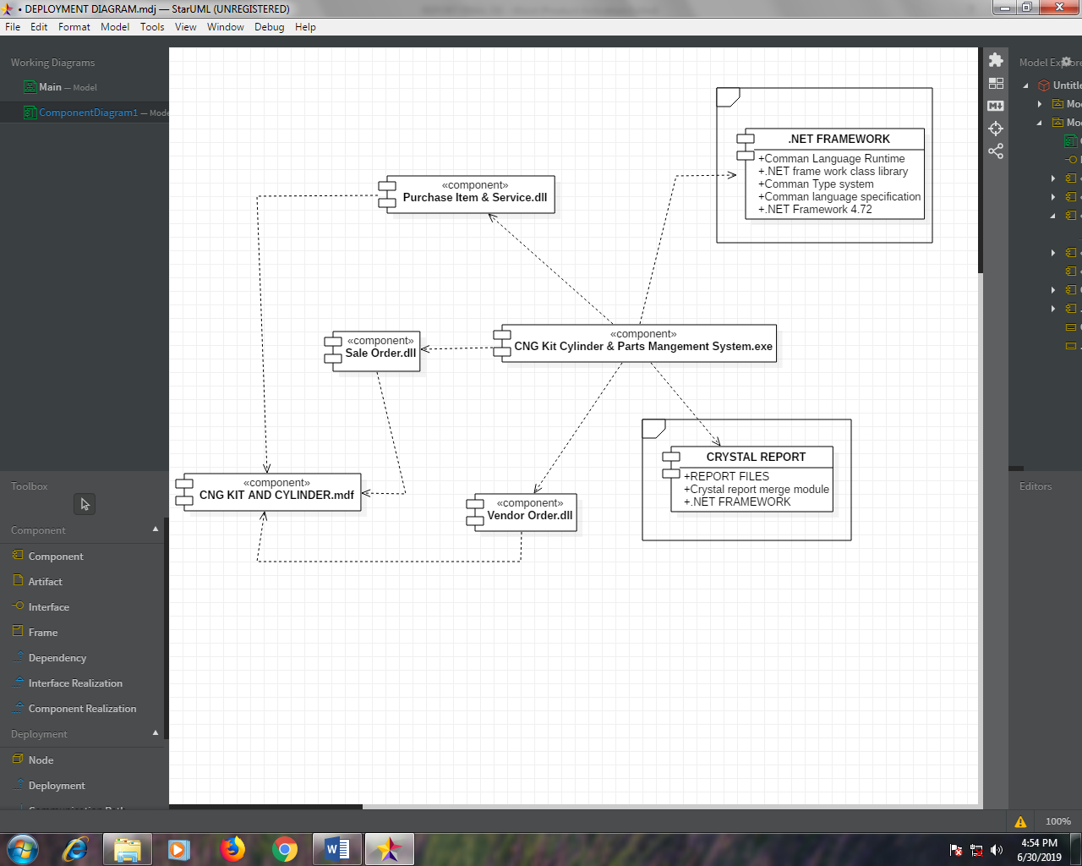

Figure COMPONENT DIAGRAM OF ENERGY ZONE APPLICATION

In **Figure 17** we have 1 exe file name as our project in which three dll and 2 frame are connected to this. And all dll files are connected to database which has extension name as mdf.

### **Deployment diagram:**

In this we see the deployment diagram of our organization.

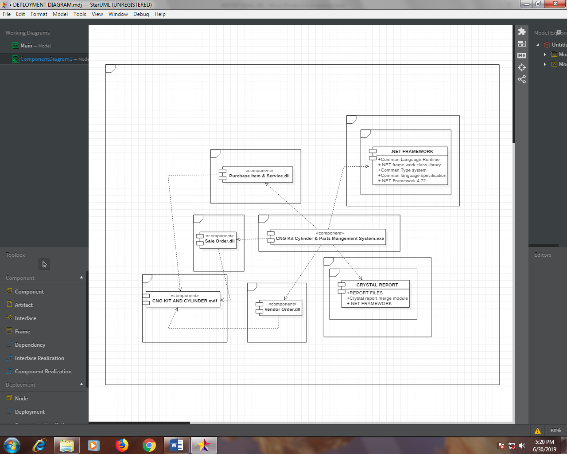

Figure DEPLOYMENT DIAGRAM OF ENERGY ZONE APPLICATION

*In* ***Figure 18*** *we placed component diagram to a frame. Component diagram in frame called as deployment diagram.*

# Support

In this we will provide the support for 6 months all problems, errors and all the updates that they can use it with no problem and for next six months we will provide the all necessary support regard from the Software issues including enhancement, maintenance, error correction and training by all members developed this project.

|  |
| --- |
| **NAME** |
| **MUHAMMAD UNAIS** |
| **SHOAIB AHMED** |
| **HASSAN AHMED** |

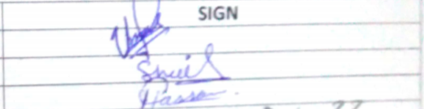

## **Conclusions and Suggestions for Future Work**

We enhanced this project to web, android and desktop for the future work also we make several reports like account ledger of sales and purchase also detailed and summary reports of all customers, items and all transaction on monthly and yearly bases.

# REFERENCE:

### **Book Reference**

1. Software Engineering: A Practitioner's Approach 8th Edition. [Roger Pressman](https://www.amazon.com/s/ref=dp_byline_sr_book_1?ie=UTF8&text=Roger+Pressman&search-alias=books&field-author=Roger+Pressman&sort=relevancerank) ,[Bruce Maxim](https://www.amazon.com/s/ref=dp_byline_sr_book_2?ie=UTF8&text=Bruce+Maxim&search-alias=books&field-author=Bruce+Maxim&sort=relevancerank).
2. Introduction to System Analysis & Design. Jaffrey L. Witten.

### **Website Reference**

1. [***https://www.cngunited.com/***](https://www.cngunited.com/)
2. [**https://www.indiamart.com**](https://www.indiamart.com/)
3. [***https://www.tomasetto.com/***](https://www.tomasetto.com/)
4. [**https://tallyfy.com/uml-diagram/**](https://tallyfy.com/uml-diagram/)

## **APPENDICES:**

In this we see all question which we ask to the organization owner. Also we see the business & reviewed documents.

**QUESTIONNAIRE**:

In this we see all question which we ask to the organization owner are below.

1. **Information of customer**

* Is it enough to taking customer information with in quick time? **YES**
* Is it necessary to record the information of the customer? **YES**
* Is it difficult to taking information about customer? **NO**
* Is there needed to separate the information of retailer and whole sales customer?

**YES**

* Is this cost are unknown /untraceable or too high? **NO**
* Is it necessary to store customer information in security? **YES for Finance department**
* Is it taking information about customer is the waste of time? **NO**
* Is effort are required for this task? **NO**

1. **Information of parts**

* Is it enough to taking parts information with in quick time? **YES**
* Is there more information needed in this task? **Yes (vehicle and its model)**
* Is it necessary to record the information of the parts which customer is required?

**YES**

* Is it difficult to taking information about parts? **NO**
* Is this cost are unknown /untraceable or too high? **NO**
* Is it necessary to store parts information in security? **YES for Finance department**
* Is this process occurring errors? **Yes by Employee**
* Is it taking information about parts is the waste of time? **NO**
* Is effort are required for this task? **NO**
* Is this process provides incorrect information? **YES for sometimes**

1. **Repairing Problem of CNG Kit**

* Is there more information needed in this task? **Yes (vehicle and its model)**
* Is it necessary to ask about repairing problem of kit which customer vehicle have?

**YES**

* Is it difficult to taking information about kit repairing problem? **NO**
* Is there any unnecessary information ‘overload information in this task? **YES**
* Is this cost are unknown /untraceable or too high? **NO**
* Is it necessary to store this problem in security? **NO**
* Is this process occurring errors? **Yes by Employee**
* Is it taking information about this is the waste of time? **NO**
* Is effort are required for this task? **NO**
* Is this process provides incorrect information? **YES for sometimes**

1. **Checking service available**

* Is there are required to check that service is available or not? **YES**
* Is this process occurring errors? **Yes by Employee**
* Is it taking information about this is the waste of time? **NO**
* Is there more information needed in this task? **Yes (Availability of employee)**

1. **Part to be fitted**

* Is any information is required which parts of the CNG kit to be fitted? **YES**

1. **Availability of kit parts**

* Is any information is required CNG kit parts which have to be fitted is either available or not? **YES**
* Is this process occurring errors? **Yes by Employee**

1. **Requirement of parts**

* Is it needed to ask about spare part of vehicle to be required by the customer? **YES**
* Is it check that part is either available or not? **YES**

1. **Ask about fitting**

* Is it require to ask required spare part of vehicle to be fitted or not? **YES**

1. **Ask about workers**

* Is it require to ask worker that he is able to repairing a vehicle? **YES**

1. **Checking stock**

* Is it require to checking stock when retailer or wholesaler while selling? **YES**
* Is it the waste of time? **Yes**
* Is this process occurring errors? **Yes by Employee**

1. **Payment method**

* Is it require to ask customer in which payment method he will choose? **YES**
* Is it privacy is required to this process? **YES**
* Is it cost effective? **NO**
* Is it take less time? **NO**

1. **Checking validation of Cheque**

* Is it required to check either cheque is valid or not? **YES**
* Is it require more time? **YES**
* Is it cost effective? **YES**
* Is it information required security? **YES**
* Is it produce reliable result? **YES**

1. **Checking account number**
   * Is it required to check either account no is valid or not? **YES**
   * Is it require more time? **YES**
   * Is it cost effective? **YES**
   * Is it information required security? **YES**
   * Is it produce reliable result? **YES**
2. **Payment completion**

* Is it required less time to payment completion process? **NO**
* Is this process form accurate result? **YES**
* Is effort is required for this process? **YES**
* Is it form an error? **YES in some times**
* Is it cost effective? **NO**

1. **Recording in finance software**

* Is record are stored in files or database? **YES**
* Is errors are occurring in this software? **YES**
* Is privacy is required to record data in this software? **YES**
* Is record data is long lasting? **NO**
* Is it provide accurate result? **YES**
* Is any effort required? **YES**
* Is record waste of time by typing or copied? **YES**

1. **Recording in customer software**

* Is record are stored in files or database? **YES**
* Is errors are occurring in this software? **YES**
* Is privacy is required to record data in this software? **YES**
* Is record data is long lasting? **NO**
* Is it provide accurate result? **YES**
* Is record waste of time by typing or copied? **YES**

1. **Published receipt**

* Is published the receipt is necessary to be given to customer through software?

**YES**

* Is it require more time? **Yes**
* Is it cost effective? **Yes**

1. **To feedback/review**

* Is it required to get feedback from customer? **YES**

**BUSINESS DOCUMENT:**

In this we see the business documents which are as under:

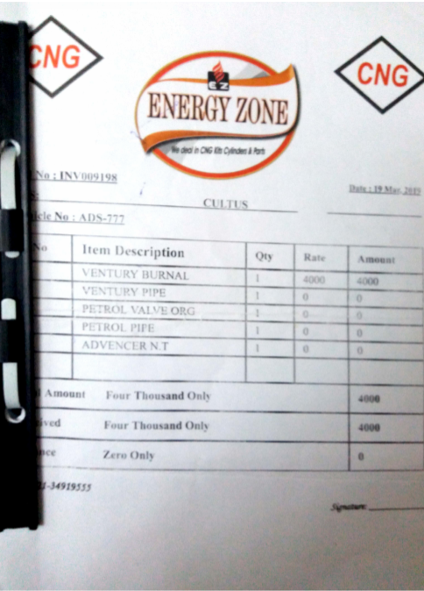 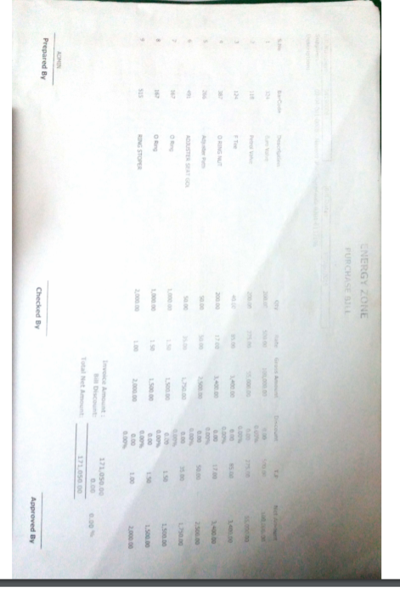

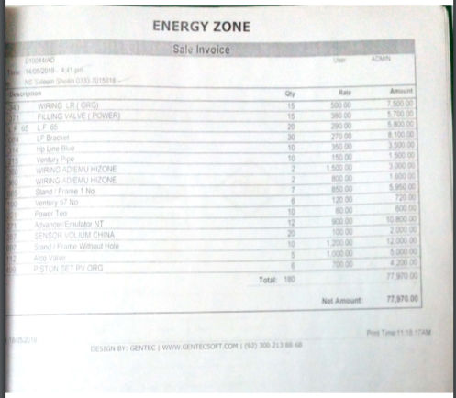 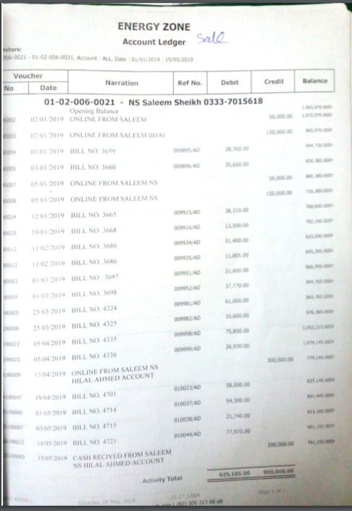

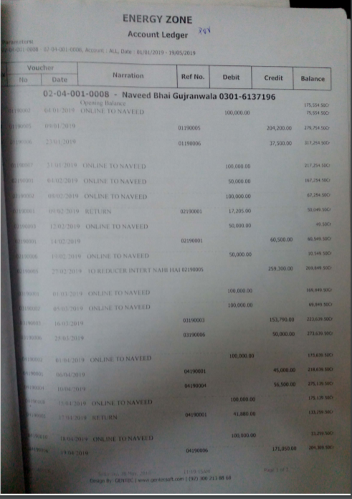

## **REVIEWED DOCUMENT:**

In this we see the reviewed documents which are as under:

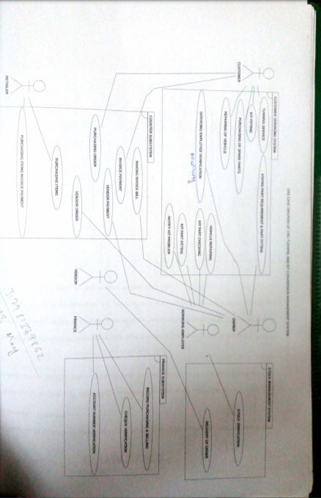 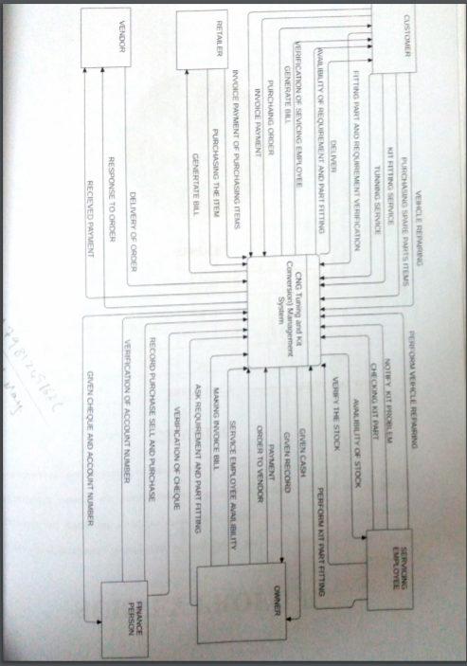

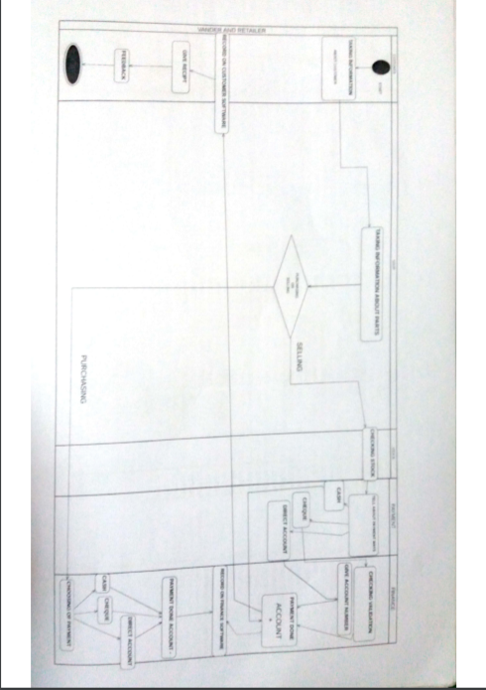 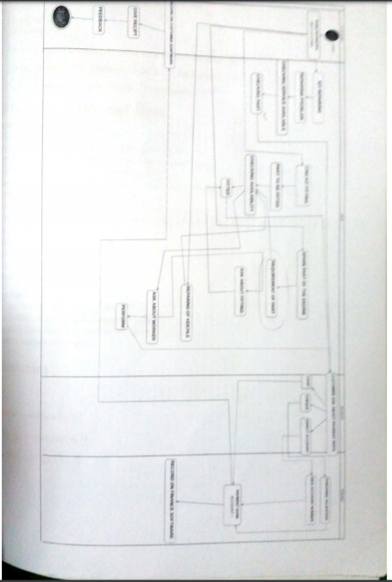

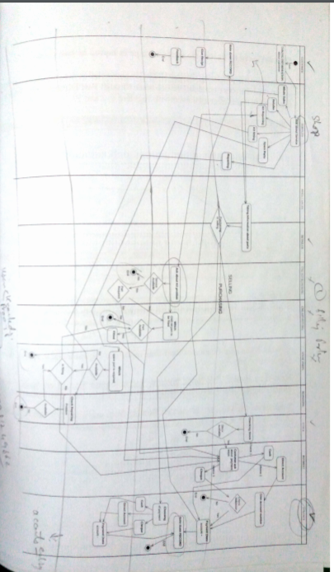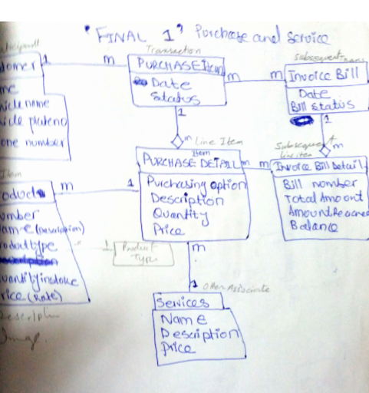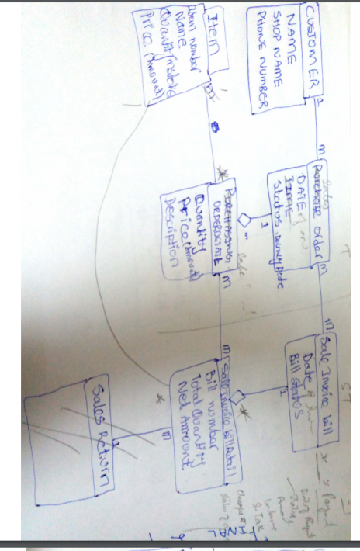

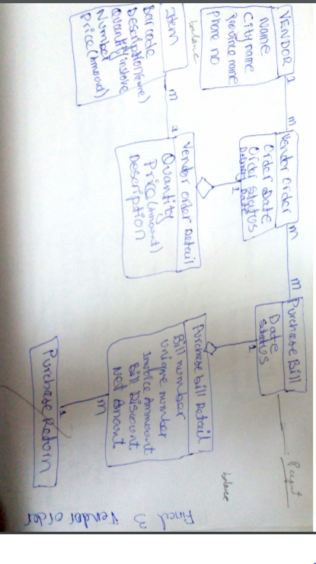

## **LIST OF SYMBOLS**

List of UML notation that are used in object oriented analysis and design.

**Class Notation**

UML *class* is represented by the following figure. The diagram is divided into four parts.

* The top section is used to name the class.
* The second one is used to show the attributes of the class.
* The third section is used to describe the operations performed by the class.
* The fourth section is optional to show any additional components.

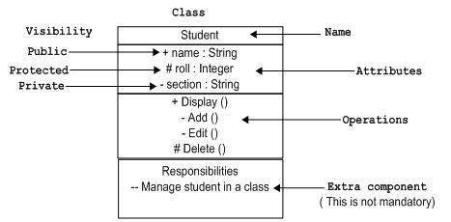

Classes are used to represent objects. Objects can be anything having properties and responsibility.

**Object Notation**

The *object* is represented in the same way as the class. The only difference is the *name* which is underlined as shown in the following figure.

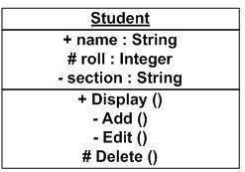

As the object is an actual implementation of a class, which is known as the instance of a class. Hence, it has the same usage as the class.

**Interface Notation**

Interface is represented by a circle as shown in the following figure. It has a name which is generally written below the circle.

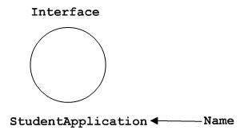

Interface is used to describe the functionality without implementation. Interface is just like a template where you define different functions, not the implementation. When a class implements the interface, it also implements the functionality as per requirement.

**Collaboration Notation**

Collaboration is represented by a dotted eclipse as shown in the following figure. It has a name written inside the eclipse.

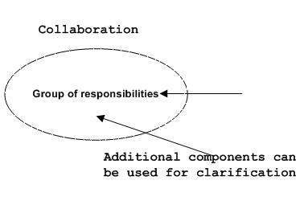

Collaboration represents responsibilities. Generally, responsibilities are in a group.

**Use Case Notation**

Use case is represented as an eclipse with a name inside it. It may contain additional responsibilities.

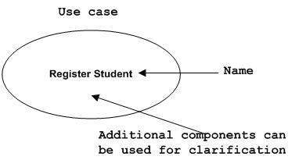

Use case is used to capture high level functionalities of a system.

**Actor Notation**

An actor can be defined as some internal or external entity that interacts with the system.

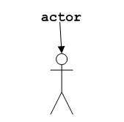

An actor is used in a use case diagram to describe the internal or external entities.

**Initial State Notation**

Initial state is defined to show the start of a process. This notation is used in almost all diagrams.

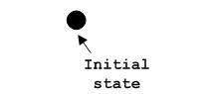

The usage of Initial State Notation is to show the starting point of a process.

**Final State Notation**

Final state is used to show the end of a process. This notation is also used in almost all diagrams to describe the end.

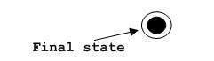

The usage of Final State Notation is to show the termination point of a process.

**Active Class Notation**

Active class looks similar to a class with a solid border. Active class is generally used to describe the concurrent behavior of a system.

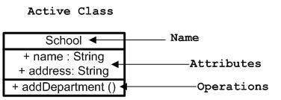

Active class is used to represent the concurrency in a system.

**Component Notation**

A component in UML is shown in the following figure with a name inside. Additional elements can be added wherever required.

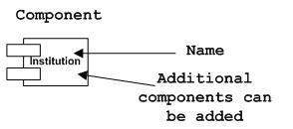

Component is used to represent any part of a system for which UML diagrams are made.

**Node Notation**

A node in UML is represented by a square box as shown in the following figure with a name. A node represents the physical component of the system.

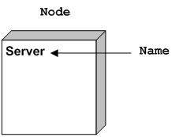

Node is used to represent the physical part of a system such as the server, network, etc.

**Behavioral Things**

Dynamic parts are one of the most important elements in UML. UML has a set of powerful features to represent the dynamic part of software and non-software systems. These features include *interactions* and *state machines*.

Interactions can be of two types −

* Sequential (Represented by sequence diagram)
* Collaborative (Represented by collaboration diagram)

**Interaction Notation**

Interaction is basically a message exchange between two UML components. The following diagram represents different notations used in an interaction.

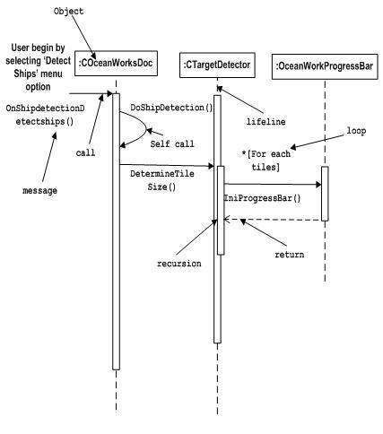

Interaction is used to represent the communication among the components of a system.

**State Machine Notation**

State machine describes the different states of a component in its life cycle. The notations are described in the following diagram.

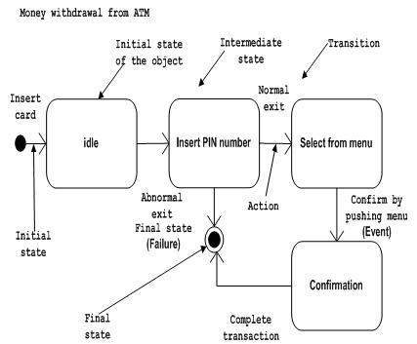

State machine is used to describe different states of a system component. The state can be active, idle, or any other depending upon the situation.

**Grouping Things**

Organizing the UML models is one of the most important aspects of the design. In UML, there is only one element available for grouping and that is package.

**Package Notation**

Package notation is shown in the following figure and is used to wrap the components of a system.

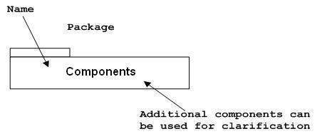

**An notational Things**

In any diagram, explanation of different elements and their functionalities are very important. Hence, UML has *notes* notation to support this requirement.

**Note Notation**

This notation is shown in the following figure. These notations are used to provide necessary information of a system.

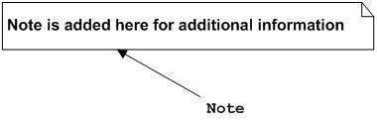

**Relationships**

A model is not complete unless the relationships between elements are described properly. The *Relationship* gives a proper meaning to a UML model. Following are the different types of relationships available in UML.

* Dependency
* Association
* Generalization
* Extensibility

**Dependency Notation**

Dependency is an important aspect in UML elements. It describes the dependent elements and the direction of dependency.

Dependency is represented by a dotted arrow as shown in the following figure. The arrow head represents the independent element and the other end represents the dependent element.

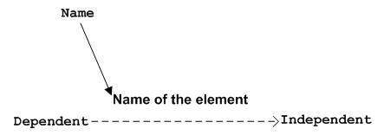

Dependency is used to represent the dependency between two elements of a system

**Association Notation**

Association describes how the elements in a UML diagram are associated. In simple words, it describes how many elements are taking part in an interaction.

Association is represented by a dotted line with (without) arrows on both sides. The two ends represent two associated elements as shown in the following figure. The multiplicity is also mentioned at the ends (1, *, etc.) to show how many objects are associated.

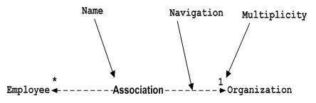

Association is used to represent the relationship between two elements of a system.

**Generalization Notation**

Generalization describes the inheritance relationship of the object-oriented world. It is a parent and child relationship.

Generalization is represented by an arrow with a hollow arrow head as shown in the following figure. One end represents the parent element and the other end represents the child element.

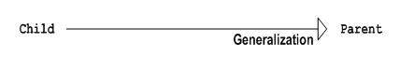

Generalization is used to describe parent-child relationship of two elements of a system.

**Extensibility Notation**

All the languages (programming or modeling) have some mechanism to extend its capabilities such as syntax, semantics, etc. UML also has the following mechanisms to provide extensibility features.

* Stereotypes (Represents new elements)
* Tagged values (Represents new attributes)
* Constraints (Represents the boundaries)

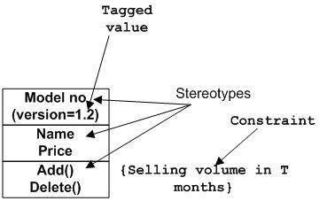

Extensibility notations are used to enhance the power of the language. It is basically additional elements used to represent some extra behavior of the system. These extra behaviors are not covered by the standard available notations.

# GLOSSARY

**Object-Oriented:**

Object-oriented methodology is a way of viewing software components and their relationships. Object-oriented methodology relies on three characteristics that define object-oriented languages: encapsulation, polymorphism, and inheritance. These three terms are elaborated below.

**Objects and Methods:**

An object is an encapsulation of data together with procedures that manipulate the data and functions that return information about the data. The procedures and functions are both called methods.

**Encapsulation:**

Encapsulation refers to mechanisms that allow each object to have its own data and methods.

### **Polymorphism:**

Polymorphism refers to the capability of having methods with the same names and parameter types exhibit different behavior depending on the receiver. In other words, you can send the same message to two different objects and they can respond in different ways.

**Overloading:**

More generally, the capability of using names to mean different things in different contexts is called overloading. This also includes allowing two methods to have the same name but different parameters types, with different behavior depending on the parameter types.

**Members**:

Objects can have their own data, including variables and constants, and their own methods. The variables, constants, and methods associated with an object are collectively referred to as its members or features.

**Classes**:

Many object-oriented languages use an important construction called a class. A class is a category of objects, classified according to the members that they have. Like objects, classes can also be implemented in classical languages, using separate compilation and struts for encapsulation.

**Inheritance**:

One important characteristic of object-oriented languages is inheritance. Inheritance refers to the capability of defining a new class of objects that inherits from a parent class. New data elements and methods can be added to the new class, but the data elements and methods of the parent class are available for objects in the new class without rewriting their declarations.

**Abstract Data Type:**

A user-defined data type, including both attributes (its state) and methods (its behaviour). An object oriented language will include means to define new types (see class) and create instances of those classes .It will also provide a number of primitive types.

**Aggregation:**

Objects that are made up of other objects are known as aggregations.

The relationship is generally of one of two types:

* Composition – the object is composed of other objects. This form of aggregation is a form of code reuse. *E.g. A Car is composed of Wheels, a Chassis and an Engine*
* Collection – the object contains other objects. *E.g. a List contains several Items; A Set several Members*.

**Primitive Type:**

The basic types which are provided with a given object-oriented programming language. *E.g. int, float, double, char, Boolean.*